Harcourt Primary School
March 2021 Return to School Handbook for Parents
We understand that after this latest partial closure of the school that many of you may have concerns about returning your child to school and this handbook is intended to address some of these concerns. Since you were last on the school site we have had to make a number of additional changes in response to guidance from the Department for Education (DFE). All of the changes that we have made are in place to keep the school as safe as possible and reduce the risk of transmission of Covid19 between any members of the community.
We will do our utmost to ensure the safety of our children and staff, but in order to do so we will need to introduce strict procedures. We hope that parents will understand that, in the interests of safety, we cannot make any exceptions to the rules laid out in this handbook.
When planning the children’s return to school we have taken full account of national guidance from the Department for Education. All guidance is based around the DFE System of Controls that were updated on the 22nd February 2021.
These state:
Schools must always:
1) Minimise contact with individuals who are required to self-isolate by ensuring they do not attend the school.
2) Ensure face coverings are used in recommended circumstances.
3) Ensure everyone is advised to clean their hands thoroughly and more often than usual.
4) Ensure good respiratory hygiene for everyone by promoting the ‘catch it, bin it, kill it’ approach.
5) Maintain enhanced cleaning, including cleaning frequently touched surfaces often, using standard products such as detergents.
6) Consider how to minimise contact across the site and maintain social distancing wherever possible.
7) Keep occupied spaces well ventilated
In specific circumstances:
8) Ensure individuals wear the appropriate personal protective equipment (PPE) where necessary.
9) Promote and engage in asymptomatic testing, where available.
Response to any infection Schools must always:
10) Promote and engage with the NHS Test and Trace process.
11) Manage and report confirmed cases of coronavirus (COVID-19) amongst the school community. 12) Contain any outbreak by following local health protection team advice.
Returning to School
To enable us to control the amount of pupils moving around the school site at any one time it has been necessary to set up a staggered drop off and staggered pick up times. The SLT have made the decision to reduce the amount of time that our staggered drop off and pick up will take as we found that this was eating significantly into our teaching time. By doing so we are able to maximise the time the children will spend in school.
On the return to school we will continue to work with the system that we had in place during Term 1&2. All children will need to be dropped off according to the children’s surnames. We once again need to stress the importance of parents only arriving at school for their prescribed pick up and drop off time as these have been designed to restrict the number of people on site at anyone time.
Timings from 8th March 2021
Children’s Surname | Start Time | Collection Time
Surnames A - G | 8.45 to 8.50 | 3.00 to 3.05
Surnames H -O | 8.50 to 8.55 | 3.05 to 3.10
Surnames P - Z | 8.55 to 9.00 | 3.10 to 3.15

How will my child enter school in the mornings?

Key Stage One

All pupils in Key Stage One will enter the school through the green gate on the KS1 playground. When dropping your child off, please wait at the main school gate at the front of the school drive until it is unlocked. Then make your way to the entrance to the KS1 playground, using the markings on the floor to ensure social distancing. You child will then walk independently across the KS1 playground and enter the building.

Please be aware that parents will not be able to enter the KS1 playground and will not be able to speak directly to the class teacher at this time.
Please see the photos below for an idea of how the social distancing measures will look like for drop off and collection:

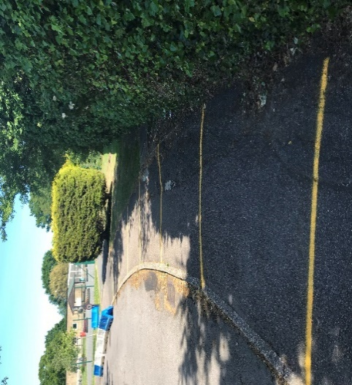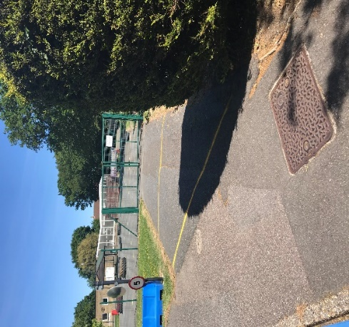

Key Stage Two

All Key Stage pupils will once again enter the school site via the KS2 playground gate. We ask you to queue on the markings on the playground. The dropping off arrangements for KS2 pupils remain exactly the same as in Term 1&2. Please can I remind all parents it is an expectation that you walk your child into school and supervise them leaving. No child should be seen running off from their parents at the end of the day. This is to ensure that all children remain safe.

How will my child leave school in the afternoon?

Our procedures for collecting the children at the end of the day remain the same as during Term 1 & 2 for both KS1 and KS2 with the exception of the slightly amended collection times. We once again ask that all parents keep strictly to our collection times.

Positive Adult Role-Models
Please can we remind all parents and carers of the need to remain positive role-models to our pupils whilst on the school site? As a school we would like to remind all members of our community to follow the rules of social distancing when accessing our site along with supporting us with the policies and procedures we have put in to support everyone’s safety.

What should my child wear to school?
On the return to school all pupils should wear full school uniform. We understand that as non-essential shops remain closed it may be difficult to buy new clothes if your children has grown during the past few months. If you find yourself in this position please don’t worry. We have no desire to add addition stress at this time.

On the return to school we continue to ask that on PE Days children come into school wearing their PE kit. A further email will be sent to you with details around the days that the children need to wear their PE kits.

What can my child bring to school with them?
Please send your child into school with:
- Their lunch box, if they will be eating a packed lunch.
- A named water bottle and enough to drink throughout the day. This is very important as we will not be able to supply children with plastic cups and we continue to have to have our water fountains turned off
- A healthy fruit snack for break time for KS2. The government continue to provide fruit for our KS1 pupils
- There reading book – further information to follow.
- All homework will now be set on Seesaw so the children do not need to bring work home from school
- Please ensure that lunchboxes and water bottles are cleaned thoroughly every evening before they are returned to school the next day.

What shouldn’t my child bring to school with them?
Please do not send in:
- Any additional bags other than a lunch box.
- Stationery – your child will have their own personalised plastic of wallet of stationary which will be kept in their trays and cleaned regularly. It will not be used by other children.
- A PE kit – this will not be needed as the children will wear PE Kit to school on the days they have PE
- Any toys or books from home.
- Any form of PPE. If a child wears PPE to school, it will be put into a sealed plastic bag and returned to them at the end of the day. This continues to follow guidance set down by the Department for Education.

Can my child where a face mask to school?
Guidance from the Department for Education states that Primary aged children should not bring face masks to school. This means that children will not be permitted to enter the school building wearing a mask. Anyone that arrives to school wearing a mask will be required to remove this and either taken home by the adult accompanying them or it will be disposed of by a member of staff.

How will my child be grouped whilst at school?
On our return to school the children will once again be in a whole class bubble. As with Term 1&2 the class will continue to have all their lessons together to minimise contact with other children in the school.

How will social distancing work for my child at school?
In its guidance, the Department for Education acknowledges that it is not possible to maintain social distancing between young children in a school setting. We cannot guarantee that your child will maintain a 2 metre distance from others in their ‘bubble’ during the school day. However, we can ensure that children and adults from separate bubbles do not mix, and that each bubble maintains a distance from others by using scheduled playtimes and staying within our classrooms for the majority of the day. We have also thought carefully about how to seat children and set up activities so that some level of social distancing is maintained within each bubble.
What will the curriculum look like?
On the children’s return to school it is our intention to teach the full national curriculum with some minor adjustments. In the first few days we will be re-establishing classroom rules and routines. The staff will be mindful of the children’s physical and emotional well-being and we will adjust the timetable if necessary. In the first few weeks the staff will be using a range of strategies to assess the children’s learning over the past two months so that we can plan how to best meet their needs during the coming weeks and months.

How do I speak to a member of staff if I have questions or concerns?
Parents will not be able to have any unscheduled face to face meetings with any member of staff at this time. If you have a concern that needs addressing, please email the office email account or phone the school office. Teaching staff will aim to reply to parents within one working day.

If your concern is urgent then a member of SLT will be available at the KS1/KS2 playground gate each morning and afternoon. We ask parents to adhere to social distancing rules if they do need to discuss a concern at the gate. Please be aware that the school office is closed to visitors and parents.

How will classrooms be cleaned?
Each classroom will be given a thorough clean at lunchtime whilst the children are outside and the end of the day once the children have left. This will include any toys or resources that the children have used. Teachers and teaching assistants will also be regularly wiping down surfaces inside the classroom throughout the day with cleaning products. We have removed any items from the classrooms that are not easily cleaned, including rugs, cushions and soft toys. Additional cleaning will also take place during lunch times by our site staff.
What will happen if my child becomes unwell whilst at school?
If your child is unwell during the school day, one of the adults from their bubble will bring them to a separate, quiet room and wait with them there. You will then be telephoned and ask to collect your child as soon as possible. Please come to the school office and ring the buzzer and we will bring your child to you. If a child displays symptoms of the virus then the same procedure will be followed and all parents who have children in the same group will be notified.

It is absolutely understandable that all parents are feeling unsure and anxious at this time. We want to re-assure you that despite the new safety measures we have put in place, your child will be treated with care and kindness by our committed staff. We hope that this handbook will have addressed any questions that you may have around re-opening, but if you have anything further you would like to know then please email us office@harcourt.kent.sch.uk.

We thank you for your on-going support and look forward to welcoming your child back to school,
The Harcourt Team

