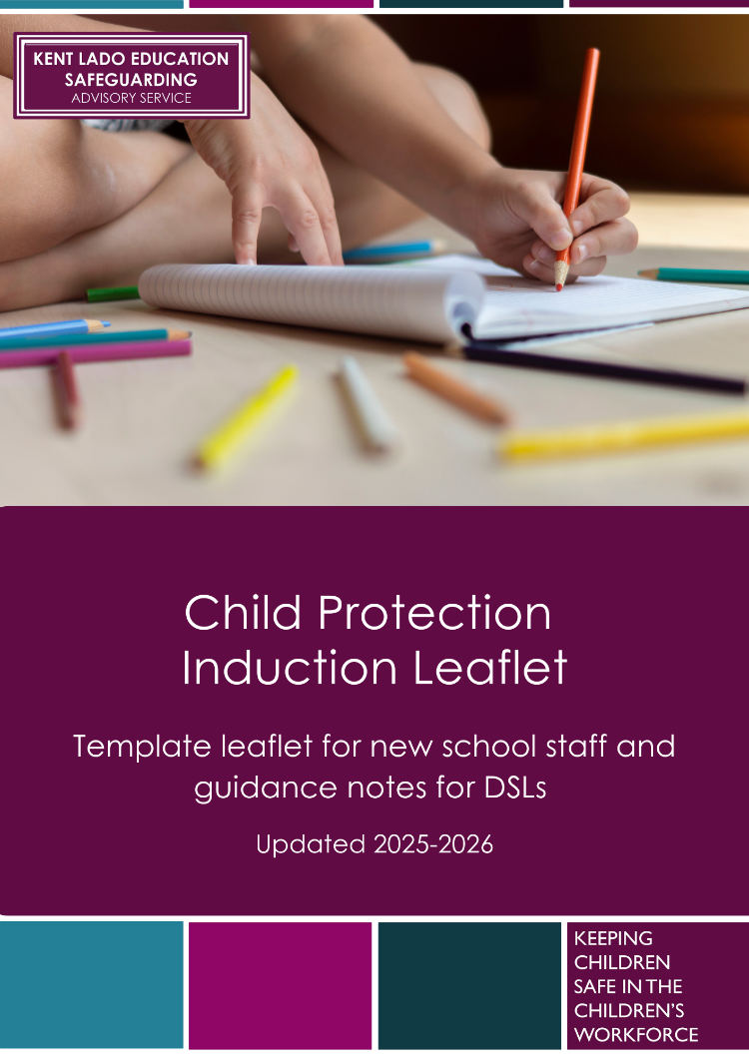
Child Protection Induction and Information Leaflet Template: Guidance

This template leaflet provides a framework for schools to use and share with staff as part of their safeguarding induction process. It can also be adapted to share with visitors and volunteers to ensure everyone understands their roles and responsibilities to safeguard children.

Schools should ensure that clear information regarding their specific safeguarding policies and processes is provided to all staff on induction. Staff should also be provided with Part One and Annex B of ’Keeping Children Safe in Education’. Staff who do not work directly with children may read Annex A instead, which is a condensed version of Part One.

Leaders and DSLs should adapt this template leaflet to include specific local information, named points of contact, as well as any specific policies, procedures and/or expectations. Text in Red is guidance notes or indicates that the school should amend/insert relevant information.

Disclaimer and Usage
The following content is provided as a starting point and should be adapted by DSLs to meet the specific requirements for their individual setting. The Kent County Council LADO Education Safeguarding Advisory Service makes every effort to ensure that the information is accurate and up to date, however, the ultimate responsibility for ensuring staff are provided with appropriate information is the responsibility of the DSL and leadership/management team. If errors are brought to our attention, we will correct them as soon as practicable.
The copyright of these materials is held by Kent County Council. However, settings that access our DSL Training Packs are granted permission to use all or part of the materials for not-for-profit use, providing the Kent County Council copyright is acknowledged.

Safeguarding Children and
Child Protection Induction
Leaflet for School Staff

2025-26



Introduction

Everyone working in or visiting our school has a responsibility to safeguard children and promote their welfare. You must be alert to signs of abuse, harm or neglect and know how to respond appropriately.

Safeguarding children is overseen by three key partners: the Local Authority (e.g. Early Help and Children’s Social Care), the Police, and Health services. Together, they form the Kent Safeguarding Children Multi-Agency Partnership (KSCMP). All staff and visitors should be familiar with the local safeguarding procedures, which align with the Working Together to Safeguard Children (2023) guidance. All staff will read, understand and have a copy of Part 1 or Annex A of ‘Keeping Children Safe in Education’ (KCSIE); (staff working directly with children will also read Annex B), ’What to do if you are worried a child is being abused’ and our child protection and related safeguarding policies as part of the induction process.

The full extent of child abuse is difficult to quantify. Research indicates that children are often unwilling to report abuse, particularly if it occurs within their family. Abusers can be individuals from any background; they may be parents, trusted adults or other children. Everyone who works with children has a responsibility to help protect them from abuse. Staff must be able to recognise potential harm, neglect and abuse, both within the setting and externally, understand how to respond to and document safeguarding concerns, and know how to make referrals when necessary.

Every school is required to have a designated safeguarding lead to take the lead responsibility for safeguarding children

The Designated Safeguarding Lead in our school is: Anthony Silk – Headteacher and Rachael Green and Victoria McWatt are our Deputy Safeguarding Leads.

…………………………………………………………..

Categories of Abuse

Physical abuse:
Can range from over-chastisement, slapping with the hand, a belt, a stick or other object, to shaking, punching or throwing a child across the room. It can lead directly to neurological damage, physical injuries, disability or – at the extreme – death. Harm may be caused by the abuse itself and by abuse taking place in a wider family, or institutional context of conflict and aggression. It also includes a parent/carer fabricating symptoms of, or inducing illness in a child. Some physical abuse is reactive; some may be clearly premeditated with intent to cause harm.

Neglect:
Can range from ignoring a child’s developmental needs, to not feeding or clothing them adequately, and not properly supervising them. Persistent neglect can lead to serious impairment of health and development, and long-term difficulties with social functioning, relationships, and educational progress. Neglect may occur by omission or commission – it is important that problems for a child’s parent do not obscure the neglect of a child in the family. Unborn babies may now be regarded as suffering neglect due to maternal substance misuse.

Sexual Abuse:
Is the involvement of a child or adolescent in sexual activities that they do not understand, cannot give consent to and which are not acceptable in our society. This includes inappropriate touching, taking of obscene photographs, producing/trading in indecent images of children (including via the internet), as well as attempted or actual sexual intercourse. Sexual abuse can be carried out by women and other children, as well as men.

Emotional Abuse:
Ranges from rejection, refusing to provide love or affection, making a child unhappy by continually belittling or verbally abusing them, and/or being made to watch the ill-treatment of others. It may also include developmentally inappropriate or overly high expectations which the child cannot fulfil. Domestic abuse, adult mental health issues and parental substance misuse are often features in families where children suffer emotional abuse. This can have a significant impact on a developing child’s mental health, behaviour and self-esteem. Serious bullying, causing a child to feel frightened or in danger may be regarded as emotional abuse.

Other Safeguarding Risks

Staff should be aware of a range of other safeguarding concerns, including Child Sexual Exploitation (CSE) Child Criminal Exploitation (CCE) and County Lines, radicalisation (The Prevent duty/agenda) and So-called ‘Honour Based Abuse’ (including Female Genital Mutilation).

More information about other forms of abuse and safeguarding issues can be found at Kent Safeguarding Children Multi-Agency Partnership and/or via Annex B of Keeping Children Safe in Education.

Child-on-Child Abuse
Children can abuse other children. It can happen both inside and outside of the setting, including online. It can include bullying, relationship abuse, physical abuse, and sexual violence and sexual harassment.

Staff are expected to challenge inappropriate behaviour between children. All reports of child-on-child abuse should be taken seriously by staff and responded to in line with our settings child protection policy.

Online Safety
The internet and related technologies provide wonderful opportunities for creativity, learning and communication, however, that there are also risks associated, including:
- Content: being exposed to illegal, inappropriate, or harmful content, for example: pornography, racism, misogyny, self-harm, suicide, anti-Semitism, radicalisation, extremism, misinformation, disinformation (including fake news) and conspiracy theories.
- Contact: being subjected to harmful online interaction with other users; for example, commercial advertising as well as grooming and online sexual exploitation.
- Conduct: personal online behaviour that increases the likelihood of, or causes, harm; for example, making and sending explicit sexual images, or cyberbullying.
- Commerce: being exposed to financial risks; for example, online gambling, inappropriate advertising, phishing, cybercrime and financial scams

Online Safety is part of our safeguarding role and responsibilities. Where there are online safety concerns, staff should follow our child protection policy and procedures, including our acceptable use of technology and mobile phones, cameras and other devices policy.

Potential Indicators of Abuse, Harm or Neglect
All staff and visitors have a duty to remain vigilant and report any concerns about a child’s welfare. Children may not always be able to verbalise abuse, so it’s important to be aware of possible signs.

Physical indicators may include:
- Unexplained bruises, burns, bite marks, or other injuries, especially in areas not typically prone to accidental injury (e.g. back, buttocks, thighs, neck, or behind the ears).
- Frequent or untreated injuries, or a pattern of repeated harm.
- Signs of neglect, such as persistent hunger, poor hygiene, or inappropriate clothing.

Behavioural indicators may include:
- Sudden changes in behaviour such as withdrawal, aggression, fearfulness, or clinginess.
- Unusual sexual knowledge or behaviour for the child’s age.
- Low self-esteem, excessive need for approval, or extreme anxiety.

If you observe any of these signs, or if something just doesn’t feel right, report your concerns to the DSL without delay. Never assume someone else will act.

What to do if you are concerned for a child
Sometimes, you may have a concern about a child but lack clear evidence that abuse is taking place. This can feel uncertain, but it’s important to remember that even vague or unconfirmed worries can be the first signs of something more serious. Many safeguarding cases have started with a “gut feeling” or small observation. It’s important staff and visitors are alert, question behaviours, seek help and refer promptly.

Always take action:
- Record any concerns, no matter how minor they may seem, and pass them on to a DSL as soon as possible.
- The DSL is responsible for gathering all available information, consulting with other professionals if needed, and deciding whether further action or a referral is required.

Recording concerns:
- Follow our child protection policy when recording concerns.
- Records must be signed, dated, and stored securely.
- Include relevant factual details, such as what was seen, said or heard, when and where it happened, and who was involved.
- All visitors to our school should complete a blue concern form that can be found in the staff room or main office.

If the DSL is unavailable, or if you believe a child is at immediate risk, or you are concerned about how a concern is being handled, you can contact the local safeguarding partners (e.g. the Police and/or Integrated Children’s Services) directly. This is in line with local and national safeguarding procedures and ensures the child’s safety remains the top priority.

What to do if a child shares a concern
It’s important to respond to concerns calmly, supportively, and promptly.
- Reassure the child that they are right to tell someone and they are not to blame.
- DO NOT promise confidentiality; explain that you may need to share what they’ve told you with other adults to help keep them safe.
- Use open-ended questions only if clarification is needed, such as Who? What? Where? When? You can also use TED prompts: Tell me… Explain… Describe… Avoid asking “why” questions or anything that might feel blaming.
- DO NOT interrogate/investigate; allow the child to speak freely and in their own words. They may need to have to disclose to a specialist later, and too much detail now may interfere with later investigations.
- When the child is finished, make sure they feel secure and explain what you are going to do next.
- Make a written record as soon as possible. Include the date, time, and exact words used by the child.
- Follow the child protection policy and report the concern to the DSL.

Allegations against members of staff
If you are concerned about the behaviour of a colleague, it is essential that you report this immediately to the headteacher in line with our allegations and staff behaviour/low-level concerns policy. Any concerns regarding the headteacher should be made to the Chair of Governors

If an allegation is made against a member of staff, the headteacher must consult with the Local Authority Designated Officer (LADO) who will advise on the appropriate next steps and ensure the allegation is managed in line with statutory guidance. If your concern is about the headteacher, follow our allegations policy; this may include reporting to the Chair of Governors, contacting the LADO directly or following our whistleblowing policy.

If you raise a concern with the headteacher or DSL and are not satisfied with the response or action taken, you must escalate the concern. Details on how to do this can be found in our allegations and whistleblowing policy.
You can also contact the NSPCC Whistleblowing Advice Line for confidential support: 0800 028 0285

Empowering children
We help children learn how to keep themselves safe and feel empowered to report any worries. This includes:
- Developing awareness and understanding of risks in an age-appropriate way as part of our Relationships Sex and Health Education (RSHE) curriculum.
- Teaching online safety
- Promoting healthy relationships and boundaries
- Embedding British Values to support understanding of rights and respect

Details of our Child Protection, Allegations against Staff, Whistleblowing and other relevant safeguarding policies are available view at: www.harcourt.kent.sch.uk or in the safeguarding folder in the staff room.

Useful Contacts

To request a consultation with a social worker from the Front Door Service, call 03000 411 111 If you need to make contact out of working hours, please call the Out of Hours Services via 03000 41 91 91

Our Designated Safeguarding Lead(s):
Anthony Silk – Headteacher
Rachael Green – Deputy Headteacher
Victoria MacWatt – Key Stage Two Leader

Worried about a Child:
Kent Integrated Children’s Services Portal: www.kscmp.org.uk/guidance/worried-about-a-child

Local Authority Designated Officer (LADO):
Local Authority Designated Officer: www.kscmp.org.uk/procedures/local-authority-designated-officer-lado

