Special Educational Needs and Disabilities (SEND) Information Report
Harcourt Primary

Inclusion Team
SEND Governor:
Wendy Settle
Inclusion Lead/SENCO/SEND Team:
Tanya O Connor
Contact No. 01303275294
toconnor@harcourt.kent.sch.uk

Approved by: | Wendy Settle
Last reviewed on: | December 2025
Next review due by: | December 2026

Contents
1. What types of SEND does the school provide for? 4
2. Which staff will support my child? 5
3. What should I do if I think my child has SEND? 7
4. What happens if the school identifies a need? 8
5. How will the school measure my child’s progress? 9
6. How will I be involved in decisions made about my child’s education? 10
7. How will my child be involved in decisions made about their education? 11
8. How will the school adapt its teaching for my child? 132
9. How will the school evaluate whether the support in place is helping my child? 143
10. How will the school ensure my child has appropriate resources? 153
11. How will the school make sure my child is included in activities alongside pupils who don’t have SEND? 154
12. How does the school make sure the admissions process is fair for pupils with SEN or a disability? 165
13. How does the school support pupils with disabilities? 175
14. How will the school support my child’s mental health and emotional and social development? 176
15. What support is in place for looked-after and previously looked-after children with SEN? 186
16. What support will be available for my child as they transition between classes or settings or in preparing for adulthood? 17
17. What support is available for me and my family? (Local Offer) 198
18. What should I do if I have a complaint about my child’s SEND support? 19
19. Supporting Documents…………………………………………………………………………………………………………….19
20. Glossary 20

Dear parents and carers,
The aim of this Information Report is to explain how we implement our SEND policy at Harcourt. In other words, we want to show you how SEND support works in our school.
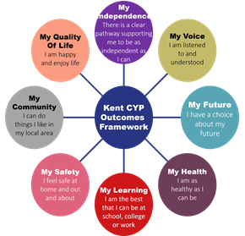
As educational professionals, we are all working towards the ultimate goal of growing independent young people as they prepare for adulthood. All provision and support we provide is working towards achieving the Kent Children and Young People (CYP) Outcomes Framework:

If you want to know more about our arrangements for SEND, read our SEND policy alongside this Information Report.
You can find our SEND policy on our website https://www.harcourt.kent.sch.uk/

Note: If there are any terms we’ve used in this information report that you’re unsure of, you can look them up in the Glossary at the end of the report.

1. What types of SEND does the school provide for?

Our school provides for pupils with the following needs (as outlined in the SEND Code of Practice 2015):

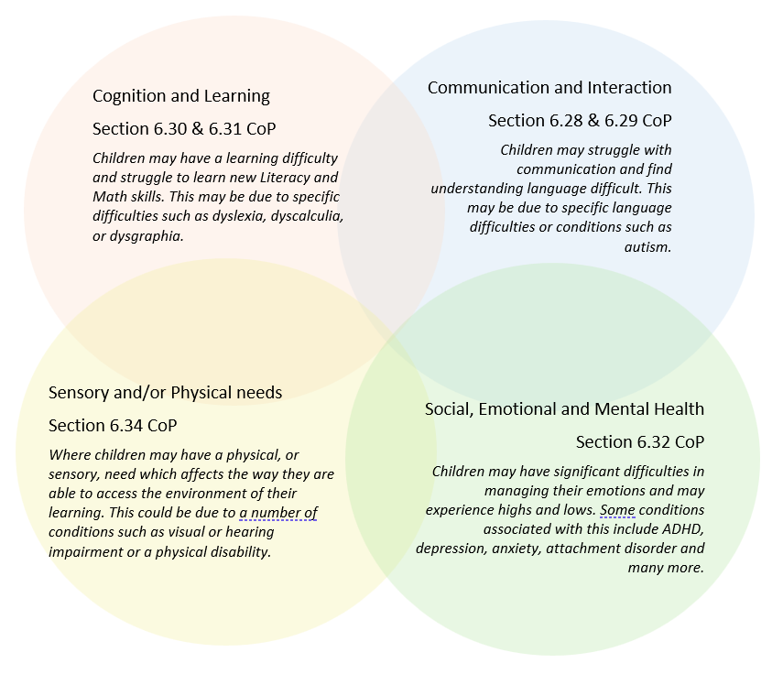

Often you will find that children’s needs overlap and are rarely confined to one area of need, which is why it is important to gain a holistic overview of your child.
More information about the Areas of Need can be found in the Special educational needs and disability code of practice: 0 to 25 years (link below).
SEND_Code_of_Practice_January_2015.pdf (publishing.service.gov.uk)


2. Which staff will support my child, and what are their key responsibilities?

At Harcourt all staff are considered responsible for supporting the needs of pupils with SEND. Our staff are committed to regular, high-quality training to ensure that they have the knowledge and skills to better meet a wide range of pupil needs.
Below outlines key staff who will be supporting your child. Please note that this list is not exhaustive.
Autism | All staff have attended AET Autism Awareness training 2024
ADHD | Tanya O ‘Connor
PDA | Tanya O ‘Connor
Sensory processing KCC CHAMP | Phillipa Relf
Play therapy | Suzanne Dullam
Bereavement counselling | Suzanne Dullam
Draw and Talk therapy | Suzanne Dullam  Kayleigh Skilling
Fizzy/gross motor skills | Katy West
Clever hands/fine motor skills | Hayley Cox  Claire Balfour
Makaton | Sarah Crichton  Hayley Cox
Attention Autism | Claire Balfour  Nicky Wellard
Speech, Language and Communication Needs | Claire Balfour
Language through Colour | Tanya O Connor  Claire Balfour  Nicky Wellard
Clicker 8 | Tanya O Connor  All staff trained 2024
Building Reading Stamina | Tracy Dennison
1st class Number | Tracy Dennison
Dyslexia/ significant Literacy difficulties | Tanya O Connor  Zoe Stevens
LEGO therapy | Phillipa Relf
Forest school leader | Emma Bleach

Our Special Educational Needs Co-ordinator, or SENCO
The named SENCO Is Tanya O Connor who holds SEN accreditation achieved in 2015.
Class/subject teachers
All of our teachers receive in-house SEN training, and are supported by the SENCO to meet the needs of pupils who have SEN. Recent training includes:
- AET autism awareness training
- Dyslexia
- Language through Colour
- ADHD
- PDA- pathological demand avoidance
- Mainstream core standards
- Fizzy and clever hands
- Attention Autism
- Precision teaching
- Speech and Language
- Makaton
- PECs
- Cued articulation
- Draw and talk therapy
- Play therapy
- Clicker 8
- LEGO therapy
- Sensory processing
- Sensory circuits
- Boxall profile
- ASD in girls
- Better Reading Stamina
- Nessy spelling
- 1st class number
- Incredible 5 point scale
- Selective mutism
- Forest school
- Bereavement counselling
- Intensive Interaction
- VERVE interaction

Teaching assistants (TAs)
We have 12 teaching assistants who are trained to deliver interventions such as
Dyslexia
Dyscalculia
Better Reading Stamina
  - phonics
Precision teaching
1st Class Number
Fizzy
Clever hands
Speech and language
Nessy spelling
Makaton
Clicker 8
Language through Colour
Draw and Talk
Play therapy

External agencies
Sometimes we need extra help to offer our pupils the support that they need. Whenever necessary we will work with external support services to meet the needs of our pupils with SEND and to support their families. These may include:

- Child and adolescent mental health services (CAMHS)
- Educational psychologists
- GPs or paediatricians
- NELFT practitioners
- Occupational therapists
- Therapeutic practitioners
- Safeguarding services
- School nurses
- KCC school health counsellors
- Porchlighht
- SEND Inclusion Advisor
- Specialist Teacher Service
- Speech and language therapists




3. What should I do if I think my child has SEND?

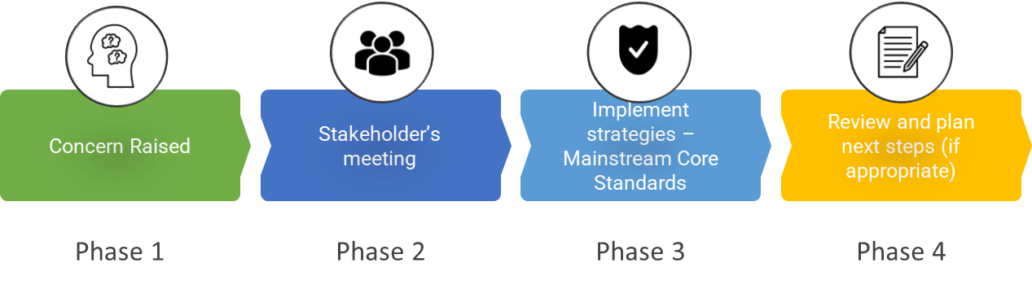

Phase 1 | If you think your child might have SEND, raise your concern with the school so that the SENCO is aware. Parents can book a meeting with their class teacher via class email address or the SENCO toconnor@harcourt.kent.sch.uk. The SENCO will complete assessments to identify needs. If the school has identified a need they will meet with the parent to discuss.
Phase 2 | We will meet with you to discuss your concerns and try to get a better understanding of what your child’s strengths and difficulties are. Together we will decide what outcomes to seek for your child and agree on next steps. We will make a note of what’s been discussed and add this to your child’s Learning Plan or personalised plan.
Phase 3 | We will implement the agreed strategies and monitor these over an agreed period of time. If SEN support these are likely to be universal or targeted strategies set out in the mainstream core standards. A copy of the MCS can be found here: https://www.kelsi.org.uk/__data/assets/pdf_file/0005/117257/Special-educational-needs-mainstream-core-standards-guide-for-parents.pdf . This will initiate the ‘Graduated Approach’ where support will be continually reviewed. See next page for more details. Staff meet the SENCO three times a year at our SEN provision meetings to review progress and update SEN Learning Plans and personalised plans.
Phase 4 | If we decide that your child needs further SEND support, we will formally notify you through writing and your child will be added to the school’s SEND register. They will receive additional support and this will be reviewed using the assess, plan, do, review model.

4. What happens if the school identifies a need?
The same process is followed if a concern is raised by the school.

All our class teachers are responsible for the monitoring of all pupils who have been identified as having SEND. They also review those who are not making the expected level of progress in their schoolwork or socially. This might include reading, writing, spelling, handwriting, Maths, Speech and Language, Physical/Sensory Needs and Social emotional needs.
If the teacher notices that a pupil is having difficulties, they try to find out if the pupil has any gaps in their learning. If they can find a gap, the school will provide appropriate support. Pupils who don’t have SEND usually make progress quickly once the gap in their learning has been filled.
If the pupil is still finding it difficult to make the expected progress, the teacher will talk to the SENCO, and will contact you to discuss the possibility that your child has SEND, and the school will follow the graduated approach (see previous page).
5. How will the school measure my child’s progress?

We will follow the ‘graduated approach’ to meeting your child’s SEND needs.
The graduated approach is a 4-part cycle of assess, plan, do, review.
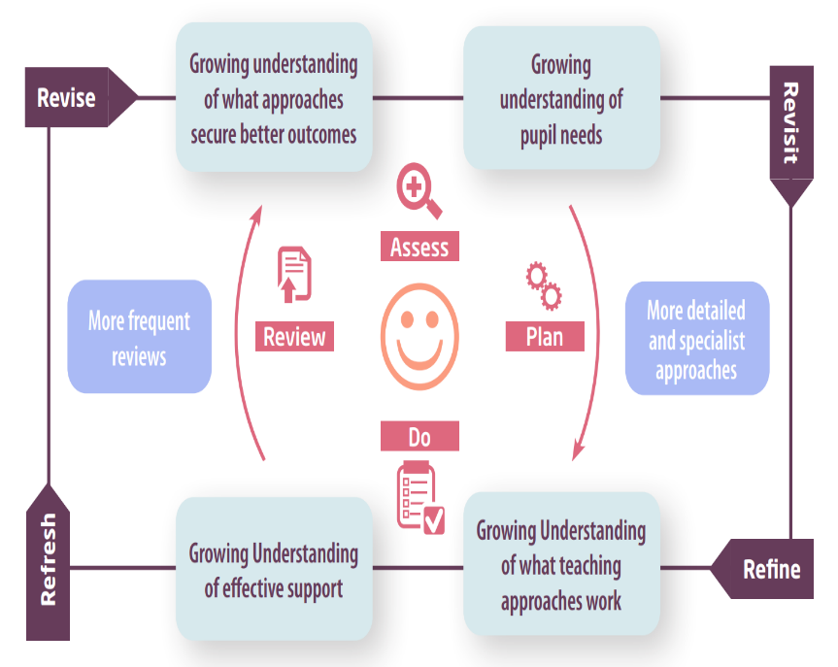

Assess | If your child is not making the expected level of progress, we will make an assessment to find out what strengths and difficulties your child has. We will ask for you and your child’s input, as well as getting help from external professionals where necessary.
Plan | In discussion with you and your child, we will decide what outcomes we are hoping to achieve. We will make a plan of the support we will offer your child to help them meet those outcomes. We will make a record of this on the child’s learning plan and share it with you and all relevant school staff.
Do | We will put our plan into practice.  The class teacher, with the support of the SENCO, will be responsible for working with your child on a daily basis, and making sure the support we put in place is having the impact we intended.
Review | We will assess how well the support we put in place helped the pupil to meet the outcomes we set. We will use our improved understanding of your child’s needs to improve the support we offer; this may mean the Plan, Assess, Do, Review cycle continues.

6. How will I be involved in decisions made about my child’s education?

We will provide you with a SEN Support Learning Plan that will be shared x 3 times a year or a personailsed plan for those with significant SEN neds.
For SEN support a member of staff who knows your child well will meet you at least three times a year to
- Set clear outcomes for your child’s progress
- Review progress towards those outcomes
- Discuss the support we will put in place to help your child make that progress
- Identify what we will do, what we will ask you to do, and what we will ask your child to do
We know that you’re the expert when it comes to your child’s needs and aspirations. So, we want to make sure you have a full understanding of how we’re trying to meet your child’s needs, so that you can provide insight into what you think would work best for your child.
We also want to hear from you as much as possible so that we can build a better picture of how the SEND support we are providing is impacting your child outside of school.
If your child’s needs or aspirations change at any time, please let us know right away so we can keep our provision as relevant as possible.
If you have concerns that arise between these meetings, please contact the class teacher on their class email or the SENCO on her email address.

7. How will my child be involved in decisions made about their education?

The level of involvement will depend on your child’s age and individual needs. We recognise that no two pupils are the same, so we will decide on a case-by-case basis, with your input.
We may seek your child’s views by asking them to:
- Attend meetings to discuss their progress and outcomes
- Prepare a presentation, written statement, video, drawing, etc.
- Discuss their views with a member of staff who can act as a representative during the meeting

- Complete a survey

8. How will the school adapt its teaching for my child?

Your child’s teacher is responsible and accountable for the progress and development of all the pupils in their class.
High-quality teaching is our first step in responding to your child’s needs. We will make sure that your child has access to a broad and balanced curriculum in every year they are at our school.
We will adapt our approaches to how we teach to suit the way the pupil works best. There is no 'one size fits all’ approach to adapting the curriculum, we work on a case-by case basis to make sure the adaptations we make are meaningful to your child and are guided by the Mainstream Core Standards in the first instance.
These adaptations may include
- Adapting our approaches, for example, giving longer processing times, pre-teaching of key vocabulary, reading instructions aloud, etc.

- Adapting our resources and staffing

- Using recommended aids, such as laptops, coloured overlays, visual timetables, larger font, etc.

- Teaching assistants or support staff will support pupils appropriately depending on their presentation of need

- Scaffolding lesson materials

- 1-1 reading support

- Small group or 1-1 phonics

- Building Reading Stamina

- 1st class number

- Fizzy – gross motor skills

- Clever hands – fine motor support

- Speech and language

- Nessy doe dyslexic pupils

- Clicker 8

- Langauge through colour

- Precision teaching

- Toe by Toe

- Attention Autism
These interventions are part of our contribution to Kent County Council’s local offer.

9. How will the school evaluate whether the support in place is helping my child?
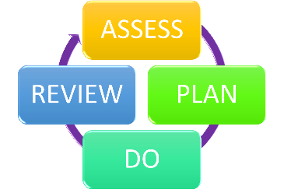
We will evaluate the effectiveness of provision for your child by:
- Reviewing their progress towards their goals x3 per year
- SENd provision meetings held with SENCO/ Class teacher/ Teaching Assistant x 3 per year
- Reviewing the impact of interventions
- Using pupil questionnaires
- Monitoring by the SENCO
- Using class provision maps to measure progress
- Holding an annual review (if they have an education, health and care (EHC) plan)

10. How will the school ensure my child has appropriate resources?
It may be that your child’s needs mean we need to provide additional resources such as:
- Additional resources to support their learning
- Adaptations to in class support
- Further training for our staff
- External specialist expertise
Where appropriate, we will consult with external agencies to get recommendations on what will best help your child access their learning and use our best endeavours to ensure these are supplied.

11. How will the school make sure my child is included in activities alongside pupils who don’t have SEND?


The expectation is that all schools providing an inclusive provision for all pupils. It may be necessary for some pupils to receive interventions in addition to a broad and balanced curriculum.
All of our extra-curricular activities and school visits are available to all our pupils, including our before and after-school clubs.
All pupils are encouraged to go on our school trips.
All pupils are encouraged to take part in sports days, Harcourt Got Talent, sporting events, after school clubs, school trips
No pupil is ever excluded from taking part in these activities because of their SEN or disability and we will make whatever reasonable adjustments are needed to make sure that they can be included.

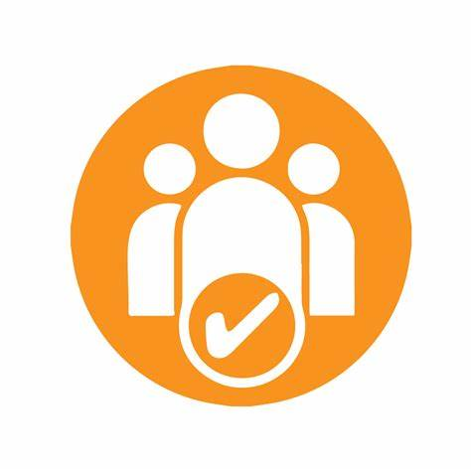
12. How does the school make sure the admissions process is fair for pupils with SEN or a disability?

At Harcourt we ensure that we don't discriminate against prospective pupils with disabilities or special educational needs (SEN) when making admission arrangements:
- Admission arrangements
We consider the needs and accessibility of prospective pupils with disabilities when making admission arrangements. We ensure that our admission arrangements don't discriminate against disabled children or those with SEN.
- Admission of pupils with a Statement of SEN
We must admit children with a Statement of SEN that names our school.
- Admission of pupils with an Education, Health and Care plan
KCC Local Authority makes decisions on the admission of pupils with an Education, Health and Care plan.
- Discrimination
It's unlawful for an education provider to discriminate against a pupil based on their disability. This includes discrimination in admission arrangements, the terms of admission, or by refusing to accept an application.
- Facilities
Harcourt provides facilities to help children with disabilities access the school, such as:
  - Disabled parking bay
  - Carpeted classrooms
  - Clearly signed routes
  - Disabled toilet

13. How does the school support pupils with disabilities?
Please see our accessibility plan on our website.


14. How will the school support my child’s mental health and emotional and social development?
We provide support for pupils to progress in their emotional and social development in the following ways:
- All pupils are observed using Leuvens x 3 per year. Pupils identified with an SEMH need are allocated appropriate internal/external support by referrals completed by the SENCO. Entry and exit SDQs are completed by parent, pupil staff to measure progress
- Boxall profile is completed and targets and strategies generated
- Pupils with SEND are encouraged to be part of the school council
- Pupils with SEND are also encouraged to be part of the forest school club to promote teamwork/building friendships
- We have a ‘zero tolerance’ approach to bullying. Please refer to the policy on our school website

15. What support is in place for looked-after and previously looked-after children with SEND?


Mr Silk the Head teacher will work with our SENCO, to make sure that all teachers understand how a looked-after or previously looked-after pupil’s circumstances and their SEND might interact, and what the implications are for teaching and learning.
Pupils who are looked-after or previously looked-after will be supported much in the same way as any other child who has SEND. However, looked-after pupils will also have a personal education plan (PEP). We will make sure that the PEP and any SEND support plans or EHC plans are consistent and complement one another.

16. What support will be available for my child as they transition between classes or settings or in preparing for adulthood?

Between years

To help pupils with SEND be prepared for a new school year we:
Arrange transition meetings between teachers
All children are provided with a transition social story
Arrange a whole school transition morning
Between schools
When your child is moving on from our school, we will ask you and your child what information you want us to share with the new setting.
Between phases.
Transition to secondary.
The SENCO and Year 6 class teacher provide a spreadsheet of need.
Secondary colleagues visit Harcourt and meet children.
Summer school activities are planned for targeted pupils.
Transition from Nursery to Secondary.
SENCO visits all Nursery settings.
X 3 stay and play afternoons are organised for all Nursery pupils.
All children receive transitioning social stories.
Individual transition meetings with STLS, SALT etc are arranged where appropriate.

17. What support is available for me and my family?
If you have questions about SEND, or are struggling to cope, please get in touch to let us know. We want to support you, your child and your family.
To see what support is available to you locally, have a look at
KCC local offer. KCC publishes information about the local offer on their website:
https://www.kent.gov.uk/education-and-children/special-educational-needs/about-the-send-local-offer
Our local special educational needs and disabilities information advice and support services (SENDIASS) organisations are:
https://local.kent.gov.uk/kb5/kent/directory/service.page?id=q8eJOMCAQOI#:~:text=Information%2C%20advice%20and%20support%20to,it%20is%20linked%20to%20education.&text=A%20free%2C%20confidential%20and%20impartial%20service%20based%20in%20Kent.

National charities that offer information and support to families of pupils with SEND are:
- IPSEA
- SEND family support
- NSPCC
- Family Action
- Special Needs Jungle

18. What should I do if I have a complaint about my child’s SEND support?
Please see our complaints policy on our website. Complaints about SEND provision in our school should be made to the SENCO in the first instance. They will then be referred to the school’s complaints policy.
If you are not satisfied with the school’s response, you can escalate the complaint. In some circumstances, this right also applies to the pupil themselves.
To see a full explanation of suitable avenues for complaint, see pages 246 and 247 of the SEND Code of Practice.
If you feel that our school discriminated against your child because of their SEND, you have the right to make a discrimination claim to the first-tier SEND tribunal. To find out how to make such a claim, you should visit: https://www.gov.uk/complain-about-school/disability-discrimination
You can make a claim about alleged discrimination regarding:
- Admission
- Exclusion
- Provision of education and associated services
- Making reasonable adjustments, including the provision of auxiliary aids and services
Before going to a SEND tribunal, you can go through processes called disagreement resolution or mediation, where you try to resolve your disagreement before it reaches the tribunal. https://www.kent.gov.uk/__data/assets/pdf_file/0011/6140/KPPS-Disagreement-Resolution-Services.pdf

19. Supporting documents

- Equality Information and Objectives Policy
- Child protection and safeguarding policy
- Behaviour Policy
- Accessibility Plan
- Attendance and punctuality policy
- SEND policy
- SEN & Disabilities Code Of Practice 2015
- Mainstream Core Standards

20. Glossary
- Access arrangements – special arrangements to allow pupils with SEND to access assessments or exams
- Annual review – an annual meeting to review the provision in a pupil’s EHC plan
- Area of need – the 4 areas of need describe different types of needs a pupil with SEND can have. The 4 areas are communication and interaction; cognition and learning; physical and/or sensory; and social, emotional and mental health needs.
- CAMHS – child and adolescent mental health services
- Differentiation – when teachers adapt how they teach in response to a pupil’s needs
- EHC needs assessment – the needs assessment is the first step on the way to securing an EHC plan. The local authority will do an assessment to decide whether a child needs an EHC plan.
- EHC plan – an education, health and care plan is a legally-binding document that sets out a child’s needs and the provision that will be put in place to meet their needs.
- First-tier tribunal/SEND tribunal – a court where you can appeal against the local authority’s decisions about EHC needs assessments or plans and against discrimination by a school or local authority due to SEND
- Graduated approach – an approach to providing SEND support in which the school provides support in successive cycles of assessing the pupil’s needs, planning the provision, implementing the plan, and reviewing the impact of the action on the pupil
- Intervention – a short-term, targeted approach to teaching a pupil with a specific outcome in mind
- Local offer – information provided by the local authority which explains what services and support are on offer for pupils with SEND in the local area
- Outcome – target for improvement for pupils with SEND. These targets don't necessarily have to be related to academic attainment
- Reasonable adjustments – changes that the school must make to remove or reduce any disadvantages caused by a child’s disability
- SENCO – the special educational needs co-ordinator
- SEN – special educational needs
- SEND – special educational needs and disabilities
- SEND Code of Practice – the statutory guidance that schools must follow to support pupils with SEND
- SEND information report – a report that schools must publish on their website, that explains how the school supports pupils with SEND
- SEND support – special educational provision which meets the needs of pupils with SEND
- Transition – when a pupil moves between years, phases, schools or institutions or life stages

