Quality First Teaching Tips Toolkit

Quality First Teaching Mats

Harcourt Primary School











Dyslexia friendly environment. Dual coded displays.
External support is accessed where necessary to support pupils.
All staff in the classroom are trained to meet the needs effectively
All staff are aware of barriers to learning and adapt where needed.
Classroom support planned for and used to maximise learning and promote independence
Quality First Teaching for all.
Always work in partnership with families, share successes and ask questions
Understanding is demonstrated in different ways
Children’s needs are quickly identified and targeted to ensure they make rapid progress.
Adaptations are made, planned and live. Assessments are used to inform next steps
My Inclusive Classroom

My Inclusive Classroom


Range of multisensory approaches used to support spoken language e.g. objects, pictures, symbols, role play








Access to a quiet space if necessary
Names are used to
cue in
The classroom environment/learning wall promotes new vocabulary. New vocabulary is shared with home
Range of methods for recording and communicating
Communication and Interaction
Instructions given in small chunks

Wait time is provided allowing time for processing and response
Rules for listening are displayed, taught and modelled
Ensure preferred level of communication is known by all staff

Explicit teaching of vocabulary
Freya model and STAR approach

Communication and interaction


‘Fussy teaching’ with high expectations of all learners -scaffolds which are gradually removed





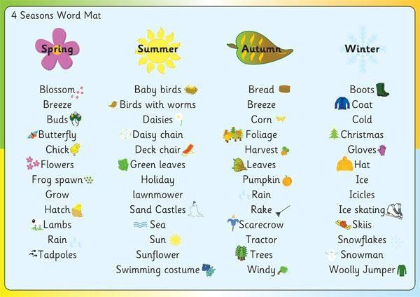
Instructions given in small instructional chunks with visual cues and in order
Links to prior learning are made regularly
Explicit teaching of Tier 3 word – Freya and STAR approach
Dyslexic friendly classroom environment – seating arrangements, IWB colors, fonts, tracking text, downloading PPT
Child friendly learning points are reviewed during and at the end of the lesson
Cognition and Learning

Wait time is provided allowing time for processing response
Explicit modelling of learning - I do, you do, we do
Pupils encouraged to explain what they have understood.

Alternative methods for planning and recording

Cognition and Learning Strategies


Catch the pupil being good and emphasise positives, celebrate strengths. Think about seating and grouping
Emotional check in’s. Positive behavior strategies
Range of multisensory approaches used to support understanding. Visual approaches used to support keeping on-task and finishing tasks
Regular observations by staff to target and support well-being and involvement. Leuvens x 3 per year






Make and model clear, explicit expectations for behaviour share successes with home too. Behaviour as a form of communication

Use ABC to identify triggers and plan for behaviours

Listen and give pupils give opportunities to explain their behaviours
Social Emotional and Mental Health



Give regular planned, legitimized learning breaks- sensory
Mainstream core standards referred to identify barrier and target support
circuits
, Access to a quiet space that
suits them when they need
it.
Emotional regulation is
Taught.

Social Emotional and Mental Health Strategies

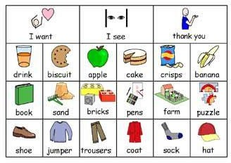









Use visuals as much as possible
Accessibility of the classroom
Think about seating/ organisation, check table heights
Sensory and/or Physical Strategies
Physical
Seating – can the pupil sit at or near the front
Check pupils understanding Ensure hearing aids are working
Allow wait and processing time
Sensory and/or Physical
Minimise classroom and environment noise
Sensory passport in place
What ways can you capture work
e.g. oral,
clicker
Break activities into smaller chunks
Think about rest breaks levels and effort needed
Hearing
Multi sensory experiences
Visual
Check
pupils’ glasses are on and clean
Consider lighting and where you stand
Limit inessential copying from the board
Say the pupil by name, cue them in


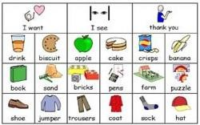


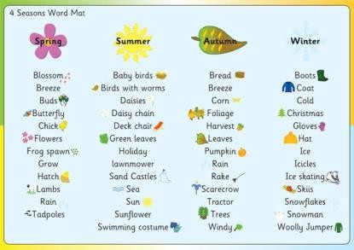
Wait time is provided allowing time for processing and response
Emphasize key words and vocabulary
STAR approach.
Range of multisensory approaches used to support understanding and language

e.g. objects, pictures, symbols, other visual prompts and timetables
Think about the sensory needs. Plan for sensory experiences and regular breaks
The child and the family are at the center

Tasks are broken down into

small chunks with visual cues, and adult interactions.
High level interactions with adults planned to develop language.
Early Years

Comment on what they are doing, join in with their play and extend language


Teaching of foundational knowledge at stage not age to close gaps quickly- group sharing of books, handwriting, number, transcription.
Explicit modelling by all adults through direct instruction and play.

Early Years Strategies

