ACORN
CLASS
NEWS



Acorn Class Term 2 Newsletter
Welcome to Acorn Class!
This letter outlines some of the main events for this half-term, messages and reminders of weekly routines relevant to Acorn Class.
Our Day
Morning Session 8.30a.m– 11.45a.m.
Afternoon Session 12.45p.m- 3.15p.m.
Morning break is 10.15a.m to 10.30a.m.

Our Class
Class Teacher: Mrs O’Donnell
Teaching Assistants: Mrs Balfour and Mrs Crichton

Spare Clothes

Please can you ensure you bring in a bag of spare clothes for your child in case they need to change due to the weather or accidents.

If we have to use spare clothes from school then please return these as soon as possible.
Toys in School

Please ensure your child does not bring toys from home into school, as we would not want these to be lost or broken.

PE and Outdoor learning
Children should wear their PE kit into school on a Thursday for outdoor learning and PE.
Please ensure all clothing is clearly named. Long hair should be tied back, and all jewellery removed for PE lessons.

PE clothes:
Plimsolls/trainers
Black Shorts/tracksuit bottoms/leggings
White t-shirt
Black jumper/hoodie

For outdoor learning please ensure your child has a full length jumper/cardigan and trousers.

Water bottles
Please ensure your child has a bottle of water with them every day so they are able to have a drink whilst in the classroom. We will try to ensure all bottles are taken home at the end of the school day.

This term we will be learning:

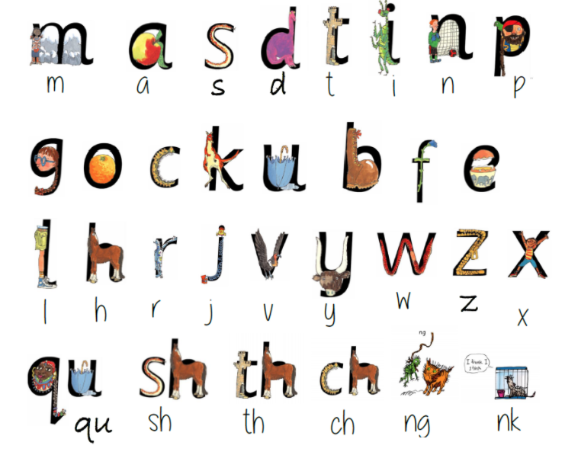
Phonics: In our Read Write Inc. sessions, some children will continue to learn the Set 1 speed sounds whilst others will focus on segmenting, spelling and reading. All of these skills will focus on developing the children’s’ reading over time.

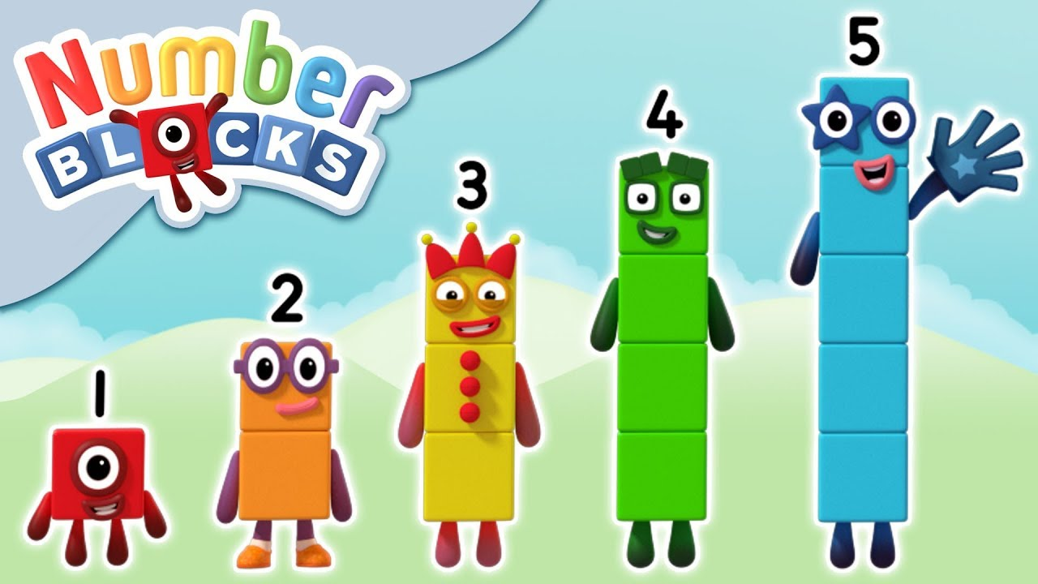
Maths: We follow the White Rose Scheme in maths. This term we will be learning about the 2D shapes (circles, triangles, squares and rectangles) and focus on using positional language. We will then focus on identifying and representing the numbers four and five in a variety of ways whilst reviewing one, two and three. We will also be learning about the concept of one more and one less.

Our Topics:
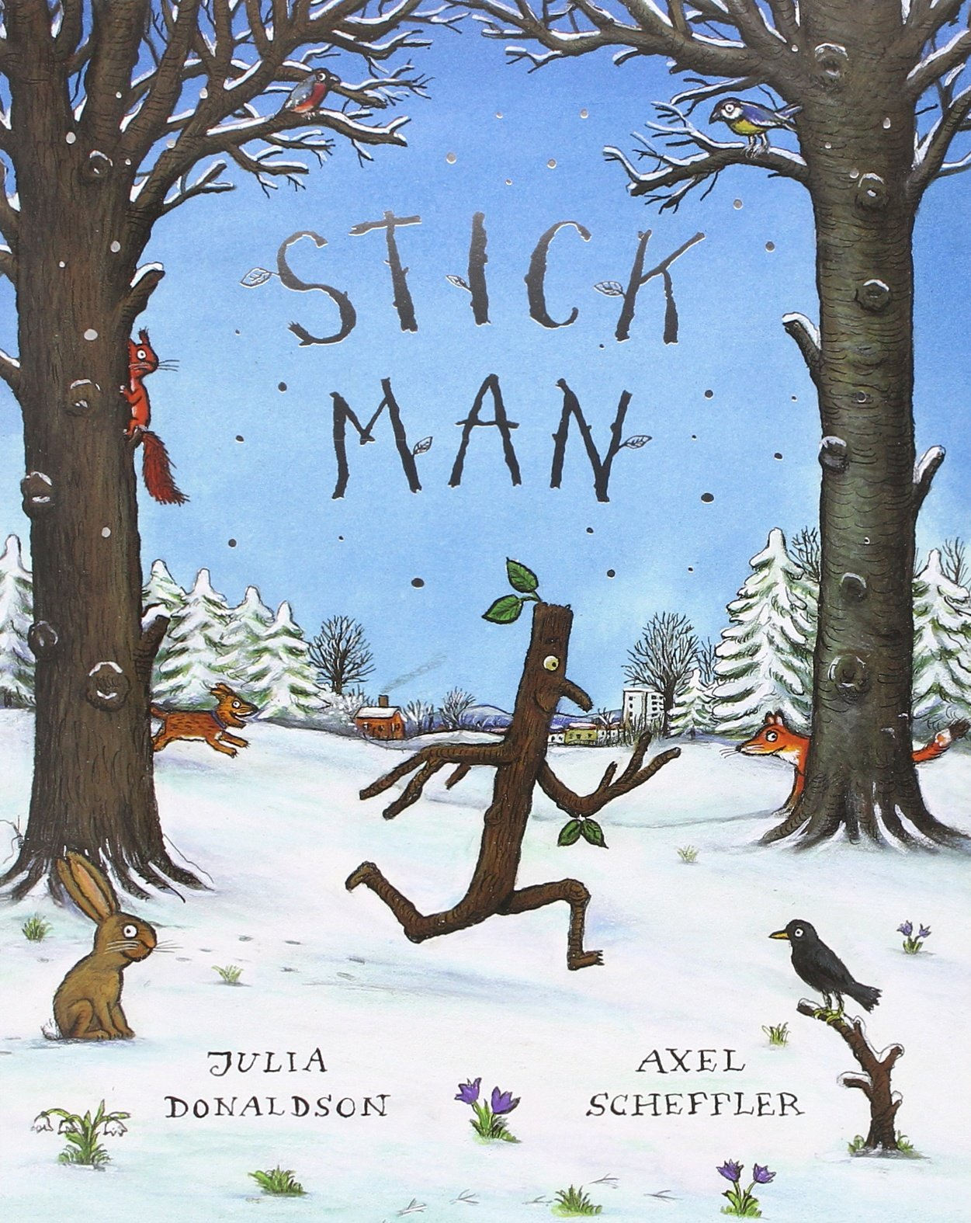
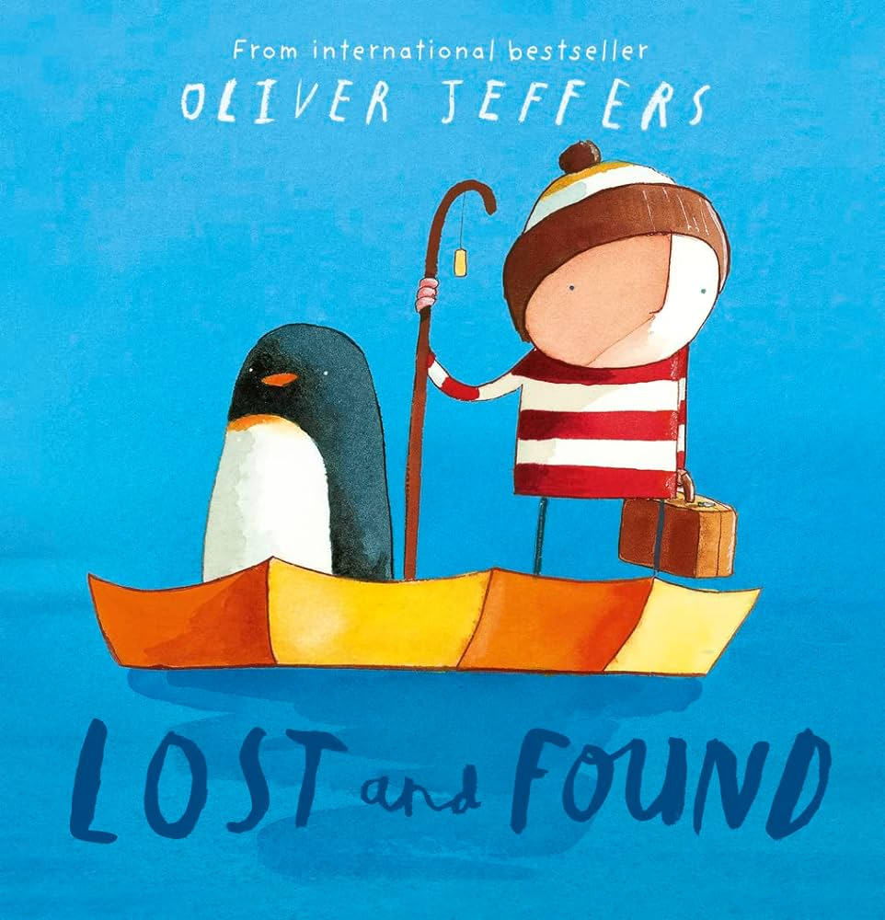
At the beginning of the term, we will continue to focus on the signs and changes of the seasons, particularly Autumn and Winter. Our current topic is all about Celebrations, so we will learn more about Diwali, Halloween and Bonfire Night, Remembrance Day and of course, Christmas. If you are celebrating anything at home, we would love to hear about it! Please post some pictures on Tapestry or bring something in for us to show – we promise to take good care of any special items. The children will be preparing for their Nativity performance with lots of singing and learning about the story of Jesus’ birth. When it gets colder, the children will have more opportunities to learn about freezing and melting ice. We will read the story ‘Stick Man’’ by Julie Donaldson. The children will have lots of opportunities to retell, role play and create props for the story. Towards the end of the term, we will be reading the story ‘Lost and Found’ by Oliver Jeffers and learn more about the North and South Pole. We will also begin to use maps, globes and non-fiction texts and compare pictures to where we live.

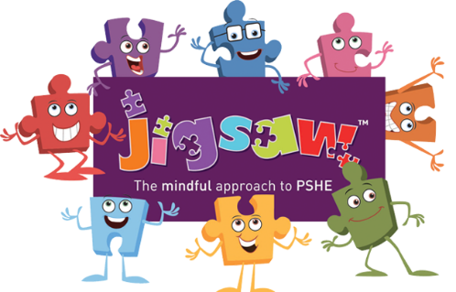
Jigsaw PSHE learning: We have weekly Jigsaw PSHE sessions. Our focus this term is ‘Celebrating differences.’ During this term, the children will think about themselves as individuals and what makes them special and unique. We will also discuss what it means to be a good friend.
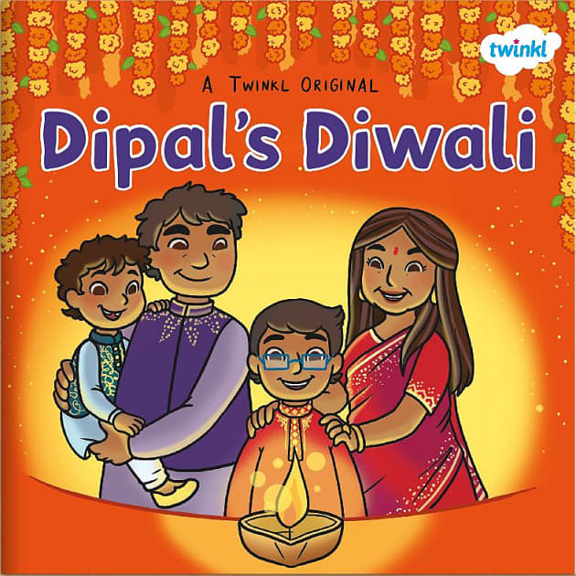

RE: Our Big Question focus this term is ‘what times are special and why?’ We will explore special occasions and how they are celebrated. The children will be encouraged to think about special times they have had. We will learn about the Diwali festival and other celebrations. We will also listen to the Nativity Story and make links to our previous learning of Christianity.

Music: We will continue to learn and sing a range of nursery rhymes. We will also begin to learn and practise songs for our Christmas Nativity Performance.

How I can support my child’s learning at home:
Daily reading at home:
Read daily with your children and record daily reading in their yellow reading record. This could include books shared at home. They will bring home a library book for you to share. These may be books that you can read to them. Reading books are changed on a Monday and a Thursday so we will need their reading packs in school.

High frequency word sets:
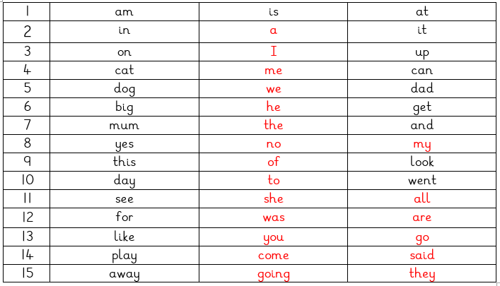
Please start to practise the high frequency word cards, which we will send home. Some of these are red words, which means they cannot be sounded out and they just need to be learnt. They will receive a new set of words once they are able to sight read their set. This means being able to recognise the words correctly without sounding them out. Once your child has learnt these words fluently, they will be given a new set of words to learn as well as recapping their previous set.
Writing at home: Please practise forming letters correctly at home, this could be in their name or they may feel confident at segmenting and writing CVC words, for example dog, cat, sun etc. If your child is unsure, please use the sheet sent home in their homework folders as the sentences help the child to form the letter.
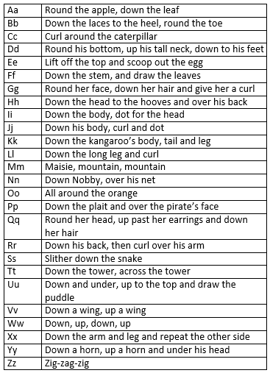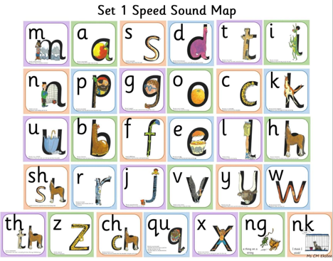

Maths at home: Each week there will be an outline of what we have been focusing on in maths in your homework folder so you are aware of our learning each week and you could continue this at home.

Basic skills: Continue to teach your children basic skills such as independently toileting, putting on their own shoes, jumpers and coats (including practising zips and buttons.)

Key dates and events this term:
Harcourt Primary School
Key Dates Term Two

Monday 27th October 2025 | INSET day.
Thursday 30th October 2025 | Halloween disco
Tuesday 4th November | Year 5 trip to London
Monday 10th November 2025 | Odd socks day
Monday 10th November 2025 | PCSO antibullying workshop for Year 6
Friday, 14th November 2025 | Children in need non-uniform day
Monday 17th November 2025 | Year 5 visit to All Soul’s Church
Wednesday, 19th November 2025 | Year R and Year 6 NHS National Child Measurement
Friday 12th December 2025 | Christmas Fayre
Tuesday 16th December 2025 | KS1 nativity
Wednesday 17th December 2025 | Christmas dinner
Wednesday 17th December 2025 | Choir singing at Laurel Court
Thursday 18th December 2025 | Christmas parties
Friday 19th December 2025 | KS2 Carols around the tree
Friday 19th December 2025 | Last day of term
Any important messages will be sent home with your child via letter, posted on our Harcourt Primary School Facebook page and/or sent to you via Bromcom.
If you do need to contact the Acorn Class Staff then please use the email address:
acorns@harcourt.kent.sch.uk
We are really looking forward to this new term ahead!
Mrs O’Donnell
Class Teacher

