HARCOURT PRIMARY SCHOOL PROGRESSION OF SKILLS – FOCUS ARTISTS
 | Year R | YEAR ONE | YEAR TWO | YEAR THREE | YEAR FOUR | YEAR FIVE | YEAR SIX
Drawing | Self portraits- mark making | Line-mark making  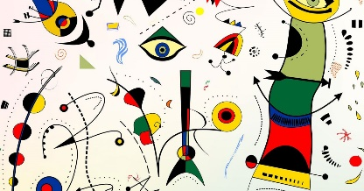  Joan Miro | 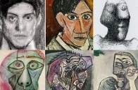  Self-portraits  Pablo Picasso  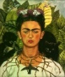  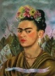  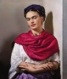  Frieda Kahlo | Tone and shading  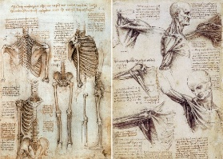  Leonardo Da Vinci | 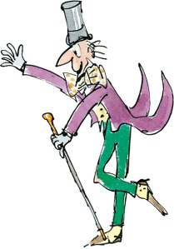  Illustrations | Perspective  L.S. Lowry  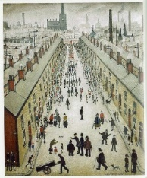 | Georgia Okeefe  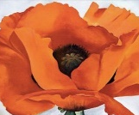
Painting | 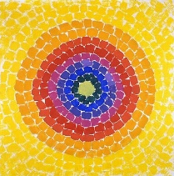  Alma Thomas  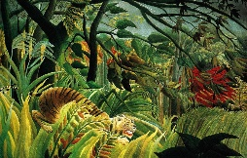  Henri Rousseau | 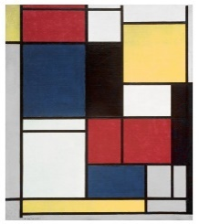  Piet Mondrian  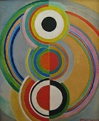  Sonia Delaunay | 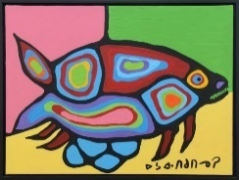  Norval Morrisseau | 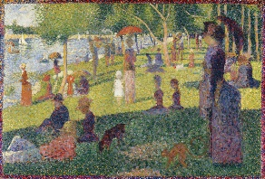  George Seurat | Yayoi Kusama  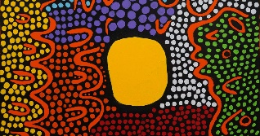 | Working collaboratively  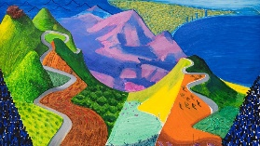David Hockney | Edward Weston photography  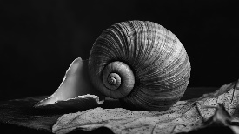  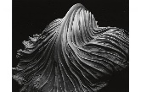
3D form/sculpture | Natural materials  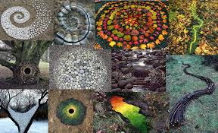  Andy Goldsworthy | Paper  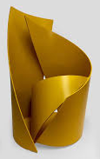  Samantha Stevenson  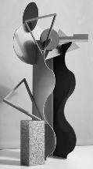  Katharina Trudzinski | 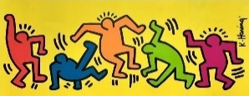  Wire  Keith Haring  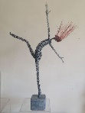  Rachel Duker | 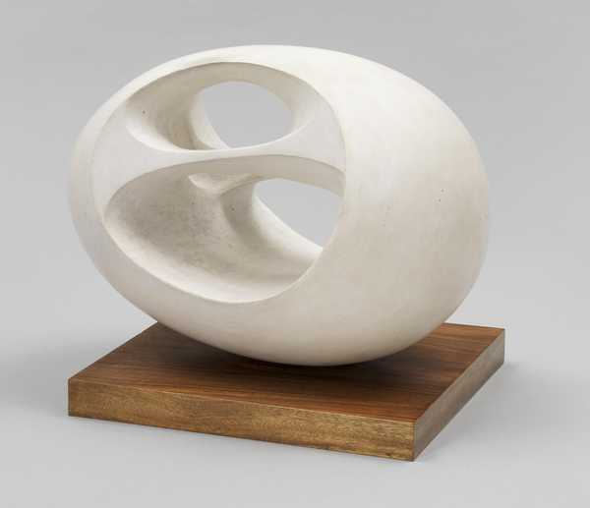  Barbara Hepworth(soap) | Faith Bebbington-use clay form and shape, line  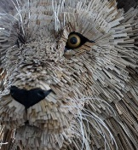 | Sonia Gomes  Sculptures using recycled materials.  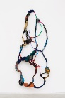  Veronika Richterová. 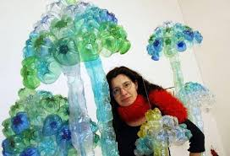 | Alexander Calder  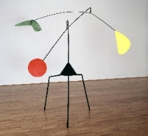  Mixed media

