16th JANUARY 2026

HARCOURT PRIMARY SCHOOL

Dear Parents and Carers,
It has been a couple of weeks since I last wrote to you and by now the Christmas holidays feel a little bit like a distant memory. Fortunately, our little part of the country has so far managed to avoid much of the bad weather except for an awful lot of rain.
We have now been back two weeks and as always, the children have returned to school very settled. Walking around the classrooms there has been a real buzz as the children enjoy their learning.
School Attendance
There was quite a lot of illness in the weeks leading up to Christmas with many children picking up horrid flu bugs. Thankfully, this now seems to have eased. Please remember children are often able to come into school with coughs and colds. If you are unsure if your child can be in school please take a look at the NHS webpage, Is my child too ill for school today - https://www.nhs.uk/live-well/is-my-child-too-ill-for-school/.
If you have any question please do not hesitate to contact the school office.
So far, our school attendance this year is 95.6%. If your child’s attendance is currently below 90% you will have received a text from the school notifying you that we are closely monitoring their attendance. If you need any support do not hesitate to contact us.
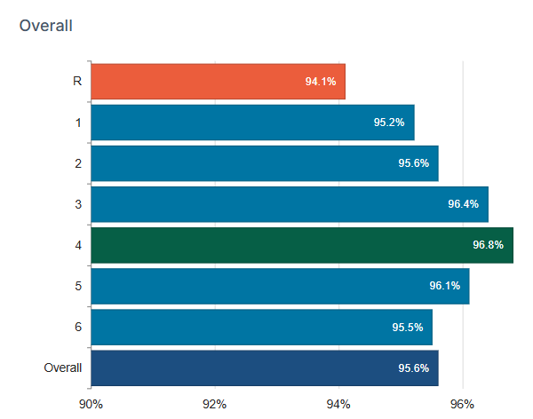
Congratulations Year 4 for having the highest attendance so far this year!
Target Documents, Class Newsletters and Knowledge Organisers
Often parents ask us how they can support their children at home with their learning or say they would like more information about what we are teaching. At the end of last term, we sent out Target Documents to all parents that outline your child’s targets that we will be working on. If you need any help with this please email the class email address.
Last week we also sent you via the MCAS app our Class Newsletters and Knowledge Organisers. Please do take a look at these to find out what is being taught this term.
NSPCC Workshops
During the past two weeks, all of our children have taken part in the national NSPCC, ‘Speak Out, Stay Safe’ assembles. As always, the children acted with great maturity during these. Well done children!
OFSTED Inspections
In the coming months/weeks we will be visited by inspectors from OFSTED. From November, the inspection framework has changed significantly. For more information about this please watch https://youtu.be/kbl0FvY976g?si=vWuQMt-3mWQqVS4R.

PTFA Quiz
As you will know, on the 29th January the PTFA will be holding their annual Family Quiz. In previous years this has been so much fun. To book a table please visit the shop section on the MCAS app. Each table costs £20, and can consist of up to 8 team members. We hope you will support us with this.
Year Six Museum Visit
Last Thursday we took our Year 6 Class to Folkestone Museum for a wonderful, hands on workshop about World War Two, the children had great fun learning about different roles that local people held such as the Land Army and Home Guard alongside making their own Anderson Shelters. Thank you to the PTFA that contributing to the cost of this visit.
Make Time for Music Piano Lessons
This term we continue to host a music teacher from Make Time for Music piano lessons. If you would like your child to have a private lesson they can be contacted by visiting the following website https://maketimeformusic.org/sign-up-now
Healthy Lunches and Drinks

In recent weeks we have seen a bit of an increase in pupils having a slightly less healthy packed lunch. The amount of food that some children have in their lunch box is more than an adult would need on any given day. Please try to keep the children’s lunch boxes as healthy as possible and don’t forget that fizzy drinks and those with sugar in should not be coming into school.
FESI Staff Development Day
Although it is a few weeks away yet, I thought I would give you a gentle reminder that the last day of term, 13th February is a staff training day.
Key Dates
5th January 2026 | First day of term
15th January 2026 | Year 6 trip to Folkestone Museum
29th January 2026 | PTFA quiz
6th February 2026 | Fire Safety Workshop
9-13th February 2026 | Children’s Mental Health week
10th February 2026 | Internet Safety Day
12th February 2026 | Last day of term
12th February 2026 | Valentines Disco
13th February 2026 | INSET day

Thank you for your continued support,
Anthony
Headteacher

Term Dates – 2025-26

Term 3
Monday 5th January 2026 | Staff Development Day 4
Tuesday 6th January 2026 | First Day of Term 3
Thursday 12th February 2026 | Last Day of Term 3
Friday 13th February 2026 | Staff Development Day 4

Term 4
Monday 23rd February 2026 | First Day of Term 4
Thursday 2nd April 2026 | Last Day of Term 4

Term 5
Monday 20th April 2026 | First Day of Term 5
Monday 4th May 2026 | School Closed – Bank Holiday
Friday 22nd May 2026 | Last Day of Term 5

Term 6
Monday 1st June 2026 | First Day of Term 6
Monday 22nd June 2026 | Staff Development Day 5
Tuesday 21st July 2026 | Last Day of Term 6

