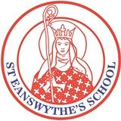
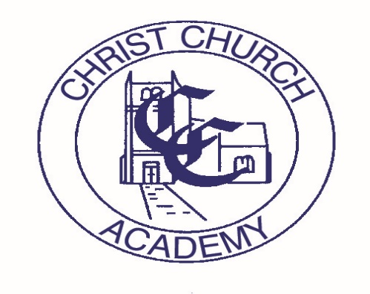
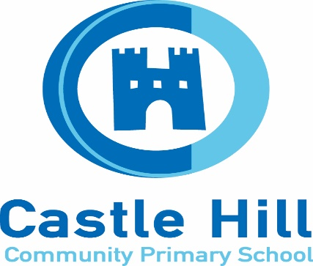
Folkestone Ethos Schools
Improvement Limited
2024 – 2025

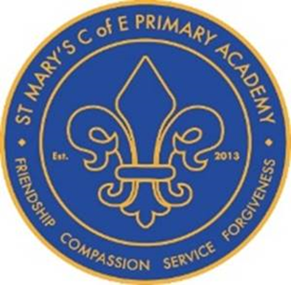

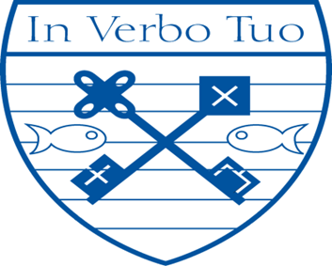

Introduction:
The governing bodies of the respective schools and academies that make up FESI recognise the value of school collaboration as a means to build capacity, sustainability and to raise standards within the individual member schools and academies.
The East Folkestone Church Schools have been collaborating in various ways for 14 years and there is general agreement that the successes of the individual schools have been due, at least in part, to the cross fertilisation that comes from joint working.
All members recognise that the joint work has to be focused and stream lined with clear recognition that its purpose is to enable individual schools to achieve their goals as well as establishing a collective values base upon which education across our locality is founded.
Benefits of our collaboration are clearly in our Membership Agreement.
Folkestone Ethos School Improvement Ltd Development Plan 2024-25
This Improvement Plan highlights our main areas for development for 2023-24
- To Enhance Collaboration and Leadership
Enhance collaboration with middle and senior leadership of FESIC schools
Improve systems of support for Sen / Pastoral teams
Establish HT peer to peer reviews

- Enhancing Cultural Capital and Experiences Beyond Curriculum
Opportunities and wider experiences in Music, Sport, Art , Forest School, Transition and Worship

- Enhancing the Curriculum Offer for All
Enhancing SEMH provision across all schools
Enhance the foundation subject curriculum knowledge and skills
Improve progress and outcomes in core subjects

Aims
The aims of our company are as follows:
- To develop a desire for learning and an enjoyment of knowledge that promotes enquiry and rational debate.
- To feel secure and confident as individuals.
- To value and respect all members of the school community: pupils, staff, parents and governors and the contribution they make towards the success of the school.
- To respect and show sensitivity to the differences between one another and to celebrate the richness this brings.

- To facilitate and improve the process of transition for our pupils on entry to primary and secondary schools.
- To develop all children to their full potential and to recognise the needs of individual children and how they can be fully supported.
- To encourage all children to become responsible, independent people who are able to think deeply about the world around them.
- To develop in children a high degree of excellence in English, mathematics, science and the aesthetic and physical areas of learning.

- Preparing a holistic curriculum tailored for the needs of our pupils

- To foster character development and enhancement of the curriculum via collective site facilities and staff expertise, eg forest schools, swimming and creative projects.
- To nurture positive attitudes towards punctuality, reliability and cleanliness.
- To help children understand the interdependence of the world in which we live and the interdependence we have with individuals, groups and nations.

For Church Schools within FESI –
- Enabling all children to flourish in the context of the Christian faith and Anglican doctrine and an ability to relate this to everyday life.

To Enhance Collaboration and Leadership
Intent | Implementation | Impact
Attendance | - Share detailed data and identify challenges 3 times per year (Set Dates) – HTs and Attendance Officers to attend (if you have one)  - Identify successful strategies  - Target strategies for persistent absentees  - Group to analyse data and agree an area of focus  - Report on successes / failures | - Attendance improves across the FESI schools  - Each school can evidence new strategies and report on effectiveness  - Schools take away new strategies and ideas
Academisation | - Meeting for Head and Chairs set for 16/09/24  - Headteachers to volunteer to speak to other FESI governors and / or staff  - Castle Hill and Christchurch to explore starting the process for other schools to follow if appropriate  - Reporting progress back to FESI Heads  - Clear agreement on way forward | - All schools continue to feel supported  - Clarity for all involved on the benefits and risks  - Governing board feel able to make informed decisions in the best interests of their school
Continue with HT peer to peer reviews | - Set dates for baseline +2 visits a year with a focus set by hosting HT as well as including additional observations from visiting HT.  - Establish agreements on how we will work together in these interactions  - Schools coming in to the Ofsted window to be identified | - Peer reviews remain a supportive process to inform school development  - Ofsted inspections remain positive
Finance officers are well supported by FESI through budget challenges | - Finance Officers make time to meet and discuss budget constraints – a Headteacher to facilitate  - Explore collaborations to secure better value  - Impact of High needs funding and how schools can collaborate | - Schools are able to continue to operate an effective budget  - Ways of saving money have been identified
Term 3 Review
Attendance will be a main agenda item for the next HT meeting.
Academisation continues to be a standing agenda item that is reviewed at each meeting.
HT peer reviews have been successful to date with two more scheduled before the next HT meeting.
Finance meetings have been taking place – unsure of content or how useful these have been. Need feedback from attendees.

Term 4 Review
Attendance data and strategies shared 2.4.25
Academisation – continues to remain as a standing agenda item. Schools continue to review individual options.
Peer to peer reviews – reviews at both Selsted and St Eanswythes have taken place. The HT of each school found the reviews a useful part of the self evaluation/school improvement process.
Finance – See above, feedback to be sought.

Term 6 Review
Attendance – data is shared regularly and strategies to support families discussed. Agreed to keep as a standing agenda item next year.
Academisation – each school is at a different point in considering joining a MAT. Agreed to keep as a standing agenda item.
HT peer-peer reviews – all HT agreed that this was a valuable experience. Notes of visit have been used at recent Ofsted inspections. All would like this element of the plan to remain.

Enhancing the Curriculum Offer for All
Intent | Implementation | Impact
To ensure standards are high in Reading, Writing and Maths and all children make good progress. | - Review, monitor and evaluate Phonics Teaching and Schemes in place in current schools.  - Sharing strategies/interventions for vulnerable readers as to how to improve reading standards.  - Reviewing interventions for Key Stage 2 vulnerable readers who have not met standards at the end of Key Stage 1.  - Reviewing, monitor and evaluate maths curriculum in regards to the focus on multiplication knowledge.  - Working with schools to increase and improve MTC outcomes across all schools.  - Review, monitor and evaluate writing curriculums and progression in genres across schools.  - CPD and focus around Greater Depth Writing across all year groups.  - Increase and improving spelling outcomes across all year groups (linked to reading and grammar). | - Phonics Screening Results will increase across all schools.  - Vulnerable readers will make good progress in reading.  - MTC results will increase all schools with the modal scores and number achieving 100% increasing.  - Staff will feel skilled in assessing Greater Depth writing and identify what a greater depth writer looks like.  - Outcomes will increase for all pupils in spelling (measured against KS2 spelling scores).
To ensure schools deliver a high-quality curriculum for all pupils. | - To continue CPD opportunities for Subject Leaders to keep abreast with subject knowledge, changes in curriculum and sharing good practice.  - Opportunities to observe other schools’ curriculums and share strategies in regards to long-term memory, vocabulary and sticky knowledge.  - Review, monitor and evaluate assessment practices across all schools in every curriculum subject.  - To use adaptive teaching to raise standards and improve progress and outcomes for all pupils. | - Subject Leaders will continue to demonstrate high quality leadership in their subject area.  - School curriculums will be strong in terms of long-term memory, vocabulary and knowledge.  - Assessment will be robust and purposeful across schools.  - Adaptive teaching will be effective in raising achievement and improving progress for all pupils.
To ensure appropriate provision and support is in place for most vulnerable pupils to flourish. | - SENCOs to share current concerns, seek advice and strategies.  - Share good practice in regard to Speech and Language and Communication.  - Reviewing alternative provision and practice in place in schools for children who are unable to access the mainstream classrooms or curriculum due to their complex needs.  - Accessing external support to develop and enhance provision in place for vulnerable pupils e.g. STLS, outside providers and using internal expertise. | - SENCOs will feel empowered to share and network with each other.  - Speech and Language and Communication provision will be high-quality with effective strategies in place.  - Effective provision will be in place for pupils who are unable to access the mainstream curriculum.  - Outside support and internal support will be strong and effective.
To ensure appropriate provision and support is in place for most vulnerable pupils to flourish.  We wanted to link this to the changing use of TAs so may want to rephrase | - SENCOs to share current concerns, seek advice and strategies.  - Share good practice in regard to Speech and Language and Communication.  - Reviewing alternative provision and practice in place in schools for children who are unable to access the mainstream classrooms or curriculum due to their complex needs.  - Accessing external support to develop and enhance provision in place for vulnerable pupils e.g. STLS, outside providers and using internal expertise. | - SENCOs will feel empowered to share and network with each other.  - Speech and Language and Communication provision will be high-quality with effective strategies in place.  - Effective provision will be in place for pupils who are unable to access the mainstream curriculum.  - Outside support and internal support will be strong and effective.
Term 3 Review
English subject leads are meeting regularly- feedback needed from group as to coverage of above objectives.
Foundation subject leader meetings are taking place – feedback from these groups at the end of the year would be useful.
SENCos have met once, however HT feel that they attend a number of meetings already and adding this one may not be useful, with the changes in Kent SEN funding and communities additional support may be needed next year - discuss further at the end of year.

Term 4 Review

Term 6 Review
Phonics results brought no surprises with varied results across the group.
Maths and English leader groups have taken place with some success but HTs believe more focus is needed for these groups. HT to discuss in more detail at the first HT meeting next academic year.
Foundation subject leaders meetings have had mixed success – smaller schools struggle to send people if they are on the same day due to teachers leading multiple subjects.
SENCos have had a busy end to the year with the start of the communities of School’. It is felt that these meetings should be adequate for next year however, HTs would request support from each other if needed.

Enhancing Cultural Capital and Experiences Beyond Curriculum
Intent | Implementation | Impact
Sport  Pupils to experience the wider opportunities for competitive and non competitive sports activities. | - Football Competitions – hub tournament (term 1) (Term 6) School to school friendly matches  - KS1 Summer Sports event  - Swimming Gala – (Feb 2025)  - Inspirational Session with talented children eg Olympic Athlete | - Widens collaboration and team skills  - Promotes a healthy lifestyle  - Provides life skills  - Increased confidence  - Enhanced social skills  - Aids Transition to Year 7  - Fosters a love of school
Art  To enhance opportunities for talented artists. | - Develop an education programme through the National gallery  - Children to have opportunities to visit the National Gallery  - Children to have opportunities to exhibit work. | - Encourages creativity and imaginative thinking  - Develops problem solving skills  - Deepens and widens knowledge  - Raises self-esteem and self-confidence.  - Aids Transition to Year 7  - Fosters a love of art  - Identifies gifted and talented artists
Science | - Develop a scientifically-centred education programme through, for example, the Science Museum  - Children to have opportunities to visit the Science Museum  - Talented children visit the Beacon to use their well-equipped lab | - Encourages scientific enquiry  - Develops critical thinking skills  - Promotes curiosity  - Deepens and widens knowledge  - Raises self-esteem and self-confidence.  - Aids Transition to Year 7  - Fosters a love of Science  - Identifies gifted and talented scientists
Transition  All Year 6 have the opportunity to meet and bond with each other before starting in secondary school. | - All Primary’s host.  - One morning in Term 6 | - Pupils can meet and establish friendships so that they are familiar with new pupils when they start secondary.  - Gives confidence and encourages resilience skills.
Worship  Church schools join together for worship so that pupils understand that Christianity is across schools. | - Harbour Worship 19th September 2024  - Child Worship Leaders to visit one another’s worships and to evaluate feedback to Headteachers  - Collective Worship Subject Leader meeting, possibly hosted at Selsted | - Pupils gain a broader understanding of their Christian distinctiveness.  - Enhanced social skills  - Aids children’s understanding of the schools collaboration through FESIC.  - Fosters a love of being part of a C of E school
Term 3 review
Football tournament was a success.
Swimming can’t take place due to the closure of Folkestone Sports Centre (This will be re-opening, date unknown)
KS1 sports event is being arranged by St E’s

Art G&T day is planned for June with a visit to The National Gallery, London
Science G&T day is planned for February with a visit to The Science Museum, London
Transition will be arranged once schools have been allocated to Year 6 pupils – AW to organise

Harbour worship was a great success.
Individual schools need to arrange to visit other school worship leaders.
A group session hosted by Selsted will be arranged for Term 6 – this could be current pupil worship leads or in preparation for next years pupil worship leaders.

Term 4 review
Sport – KS1 sports event booked for 17th June 2025
Art – visit planned for June
Science – planned visit went ahead in Feb and was a great success
Transition – Children have been allocated schools and AW will begin to collate schools for the transition event on 12th June 2025
Worship – Liaison needed for worship leaders to attend each others schools – AW will email a suggested schedule to HT of the church schools.

Term 6
This has been a really successful area of the plan with all events taking palce and being a huge success.
HTs agreed for all area of this part of the plan to continue and for us to increase the number of opportunities if possible.

