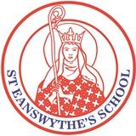
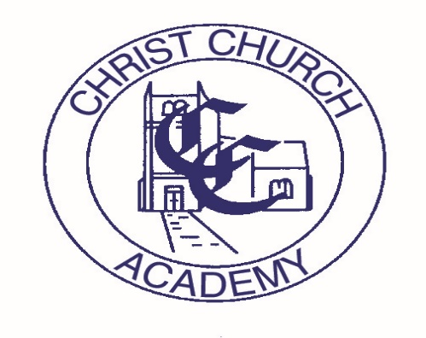
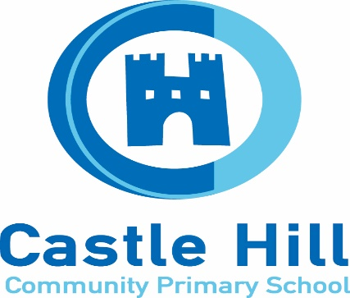
Folkestone Ethos Schools
Improvement Limited
2025 – 2026

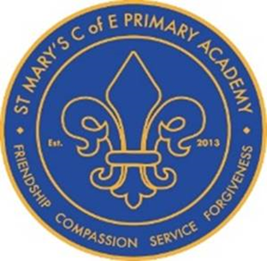
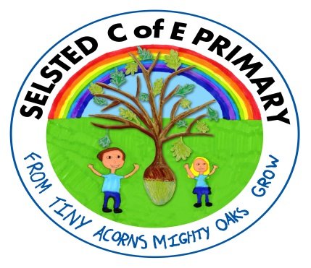
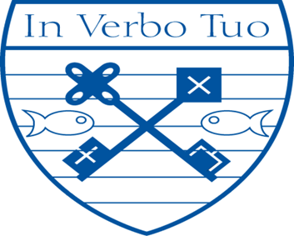

Introduction:
The governing bodies of the respective schools and academies that make up FESI recognise the value of school collaboration as a means to build capacity, sustainability and to raise standards within the individual member schools and academies.
The East Folkestone Church Schools have been collaborating in various ways for 14 years and there is general agreement that the successes of the individual schools have been due, at least in part, to the cross fertilisation that comes from joint working.
All members recognise that the joint work has to be focused and stream lined with clear recognition that its purpose is to enable individual schools to achieve their goals as well as establishing a collective values base upon which education across our locality is founded.
Benefits of our collaboration are clearly in our Membership Agreement.
Folkestone Ethos School Improvement Ltd Development Plan 2025-26
This Improvement Plan highlights our main areas for development for 2025-26
- To Enhance Collaboration and Leadership

- Enhancing Cultural Capital and Experiences Beyond Curriculum

- Enhancing the Curriculum Offer for All

Aims
The aims of our company are as follows:
- To develop a desire for learning and an enjoyment of knowledge that promotes enquiry and rational debate.
- To feel secure and confident as individuals.
- To value and respect all members of the school community: pupils, staff, parents and governors and the contribution they make towards the success of the school.
- To respect and show sensitivity to the differences between one another and to celebrate the richness this brings.

- To facilitate and improve the process of transition for our pupils on entry to primary and secondary schools.
- To develop all children to their full potential and to recognise the needs of individual children and how they can be fully supported.
- To encourage all children to become responsible, independent people who are able to think deeply about the world around them.
- To develop in children a high degree of excellence in English, mathematics, science and the aesthetic and physical areas of learning.

- Preparing a holistic curriculum tailored for the needs of our pupils

- To foster character development and enhancement of the curriculum via collective site facilities and staff expertise, eg forest schools, swimming and creative projects.
- To nurture positive attitudes towards punctuality, reliability and cleanliness.
- To help children understand the interdependence of the world in which we live and the interdependence we have with individuals, groups and nations.
- To provide valuable and effective support for leaders at all levels

For Church Schools within FESI –
- Enabling all children to flourish in the context of the Christian faith and Anglican doctrine and an ability to relate this to everyday life.

To Enhance Collaboration and Leadership
Intent | Implementation | Impact
Continue with HT peer to peer reviews | - Set dates for baseline +2 visits a year with a focus set by hosting HT as well as including additional observations from visiting HT.  - Establish agreements on how we will work together in these interactions  - Schools coming in to the Ofsted window to be identified | - Peer reviews remain a supportive process to inform school development  - Ofsted inspections remain positive
Finance | - Finance Officers make time to meet and discuss budget constraints – a Headteacher to facilitate  - Explore collaborations to secure better value  - Impact of High needs funding and how schools can collaborate | - Schools are able to continue to operate an effective budget  - Ways of saving money have been identified
New leaders are supported through collaboration | - New subject leaders are paired through subject leader meetings  - Other new leaders (SENCo) to be paired with appropriate established leaders from other schools | - Subject leaders will be effective in their own schools  - Leaders will have the knowledge to fulfil their roles
Support all schools to develop sustainability plans (or something around environment?)

Enhancing the Curriculum Offer for All
Intent | Implementation | Impact
To ensure standards are high in Reading, Writing and Maths and all children make good progress.  We wanted to keep this but may want to ammedn for specifics – GD writing we definitely wanted to keep | - Review, monitor and evaluate Phonics Teaching and Schemes in place in current schools.  - Sharing strategies/interventions for vulnerable readers as to how to improve reading standards.  - Reviewing interventions for Key Stage 2 vulnerable readers who have not met standards at the end of Key Stage 1.  - Reviewing, monitor and evaluate maths curriculum in regards to the focus on multiplication knowledge.  - Working with schools to increase and improve MTC outcomes across all schools.  - Review, monitor and evaluate writing curriculums and progression in genres across schools.  - CPD and focus around Greater Depth Writing across all year groups.  - Increase and improving spelling outcomes across all year groups (linked to reading and grammar). | - Phonics Screening Results will increase across all schools.  - Vulnerable readers will make good progress in reading.  - MTC results will increase all schools with the modal scores and number achieving 100% increasing.  - Staff will feel skilled in assessing Greater Depth writing and identify what a greater depth writer looks like.  - Outcomes will increase for all pupils in spelling (measured against KS2 spelling scores).
To ensure schools deliver a high-quality curriculum for all pupils. | - To continue CPD opportunities for Subject Leaders to keep abreast with subject knowledge, changes in curriculum and sharing good practice.  - Opportunities to observe other schools’ curriculums and share strategies in regards to long-term memory, vocabulary and sticky knowledge.  - Review, monitor and evaluate assessment practices across all schools in every curriculum subject.  - To use adaptive teaching to raise standards and improve progress and outcomes for all pupils. | - Subject Leaders will continue to demonstrate high quality leadership in their subject area.  - School curriculums will be strong in terms of long-term memory, vocabulary and knowledge.  - Assessment will be robust and purposeful across schools.  - Adaptive teaching will be effective in raising achievement and improving progress for all pupils.
To ensure appropriate provision and support is in place for most vulnerable pupils to flourish.  We wanted to link this to the changing use of TAs so may want to rephrase | - SENCOs to share current concerns, seek advice and strategies.  - Share good practice in regard to Speech and Language and Communication.  - Reviewing alternative provision and practice in place in schools for children who are unable to access the mainstream classrooms or curriculum due to their complex needs.  - Accessing external support to develop and enhance provision in place for vulnerable pupils e.g. STLS, outside providers and using internal expertise. | - SENCOs will feel empowered to share and network with each other.  - Speech and Language and Communication provision will be high-quality with effective strategies in place.  - Effective provision will be in place for pupils who are unable to access the mainstream curriculum.  - Outside support and internal support will be strong and effective.

Enhancing Cultural Capital and Experiences Beyond Curriculum
Intent | Implementation | Impact
Sport  Pupils to experience the wider opportunities for competitive and non competitive sports activities. | - Football Competitions – hub tournament (term 1) (Term 6) School to school friendly matches  - KS1 Summer Sports event  - Swimming Gala – (Feb 2025)  - Inspirational Session with talented children eg Olympic Athlete | - Widens collaboration and team skills  - Promotes a healthy lifestyle  - Provides life skills  - Increased confidence  - Enhanced social skills  - Aids Transition to Year 7  - Fosters a love of school
Art  To enhance opportunities for talented artists. | - Develop an education programme through the National gallery  - Children to have opportunities to visit the National Gallery  - Children to have opportunities to exhibit work. | - Encourages creativity and imaginative thinking  - Develops problem solving skills  - Deepens and widens knowledge  - Raises self-esteem and self-confidence.  - Aids Transition to Year 7  - Fosters a love of art  - Identifies gifted and talented artists
Science | - Develop a scientifically-centred education programme through, for example, the Science Museum  - Children to have opportunities to visit the Science Museum  - Talented children visit the Beacon to use their well-equipped lab | - Encourages scientific enquiry  - Develops critical thinking skills  - Promotes curiosity  - Deepens and widens knowledge  - Raises self-esteem and self-confidence.  - Aids Transition to Year 7  - Fosters a love of Science  - Identifies gifted and talented scientists
Transition  All Year 6 have the opportunity to meet and bond with each other before starting in secondary school. | - All Primary’s host.  - One morning in Term 6 | - Pupils can meet and establish friendships so that they are familiar with new pupils when they start secondary.  - Gives confidence and encourages resilience skills.
Worship  Church schools join together for worship so that pupils understand that Christianity is across schools. | - Harbour Worship 24th September 2025  - Child Worship Leaders to visit one another’s worships and to evaluate feedback to Headteachers  - Collective Worship Subject Leader meeting, possibly hosted at Selsted | - Pupils gain a broader understanding of their Christian distinctiveness.  - Enhanced social skills  - Aids children’s understanding of the schools collaboration through FESIC.  - Fosters a love of being part of a C of E school

