Key Vocabulary | Definition
London | The capital city of the United Kingdom.
River Thames | The river that runs through London
Tower of London | An important castle in London. It is where the crown jewels are kept.
The Monument | An important landmark in London, It was built after the Fire of London so that people would remember it.
Pudding Lane | The street in London where the fire started.
King Charles II | The King of England during the Great Fire of London
Samuel Pepys | A famous writer who wrote about the Great Fire of London in his diary.
Thomas Farriner | The baker whose bakery caught fire.
Diary | A book that you write your thoughts in.
Gunpowder | A powder that explodes if you light it.
Narrow | Close together.
Source | A person or book that provides information about an event.
2nd September 1666 | The day the fire started.

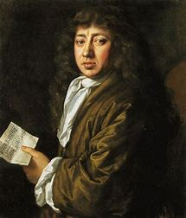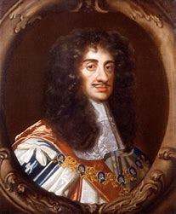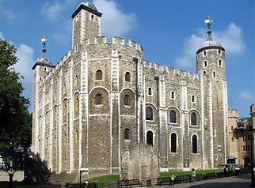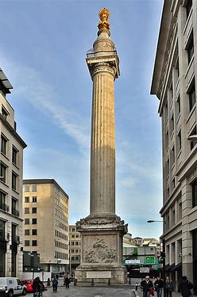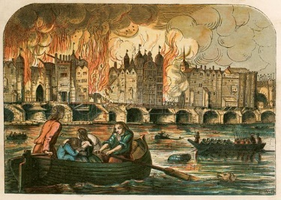
Samuel Pepys King Charles II The Tower of London The Monument The River Thames

