Harcourt Knowledge Organiser – Year 4 – The Romans
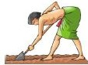 | 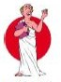 | 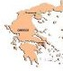 | 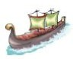 | 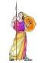 | 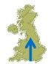 | 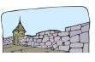 | 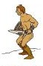 | 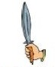 | 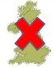 | 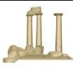 | 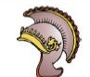
793 BC  Building of Rome begins | 510 BC  Rome becomes a republic | 130 BC  Conquer Greece and most of Spain | 43 AD  Romans invade Britain | 61 AD  Boudica’s rebellion | 71 AD  Romans conquer northern England | 122 AD  Begin building Hadrian’s wall | 200 AD  Barbarians attack the Roman Empire | 235-285 AD  Over 20 Roman emperors killed | 410 AD  Roman rule in Britain ends | 455 AD  Vandals destroy Rome | 1453 AD  Eastern empire fallls to the Turks
Key People Engineering and Construction
Bridges | The Romans built long durable bridges. Many of their bridges still stand today.
Roads | Roman Roads allowed for easier movement between towns and cities.
The Colosseum | The Colosseum was a large outdoor stadium that could seat around 50,000 people for various forms of entertainment such as gladiator games, mock battles, and dramas.
Aqueducts | Aqueducts were long channels that the Romans built to carry water into the cities.

Julius Caesar | He was a great soldier and general. He helped to take over new land for the Roman Empire.
Augustus | Augustus was the nephew of Caesar and the first Emperor of Rome.
Claudius | Claudius was the emperor who conquered Britain.
Hadrian | Hadrian became emperor after Trajan in AD 117, when the empire was at its largest.
Boudica | Queen of the British Celtic Iceni tribe who led an uprising against the Roman Empire.

Barbarian | A human considered un-civilized or primitive.
Conquer | Overtake/take control by military force.
Rebellion | An act of armed resistance to a leader/government.
Republic | A state which is run by elected representatives.
Vandals | A Germanic tribe that ransacked the city of Rome.
Empire | A group of states/countries led by a single monarch.
Vocabulary


