Key Vocabulary | Definition
Antarctica | The continent around the South Pole.
Arctic | The region around the North Pole.
Inuit | A member of a group that come from northern Canada and parts of Greenland and Alaska.
Inuksuk | An inuksuk is a manmade stone landmark or cairn built for use by the Inuit.
Explorer | A person who travels in search of geographical or scientific information.
Continent | One of the seven great divisions of land on the globe.
Aurora | A Natural light display in the Earth's sky also known as the Northern Lights.
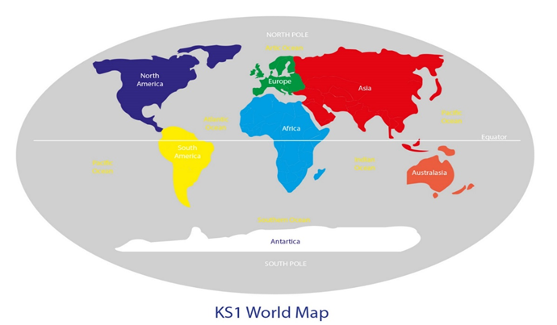
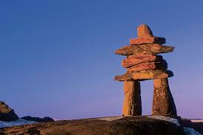
Sir Ernest Shackleton

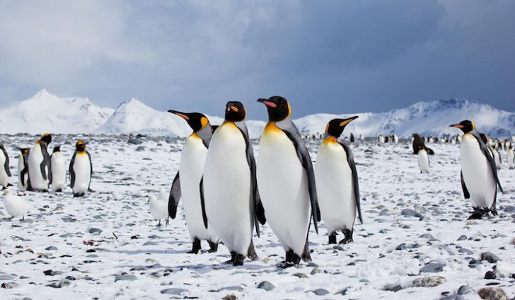
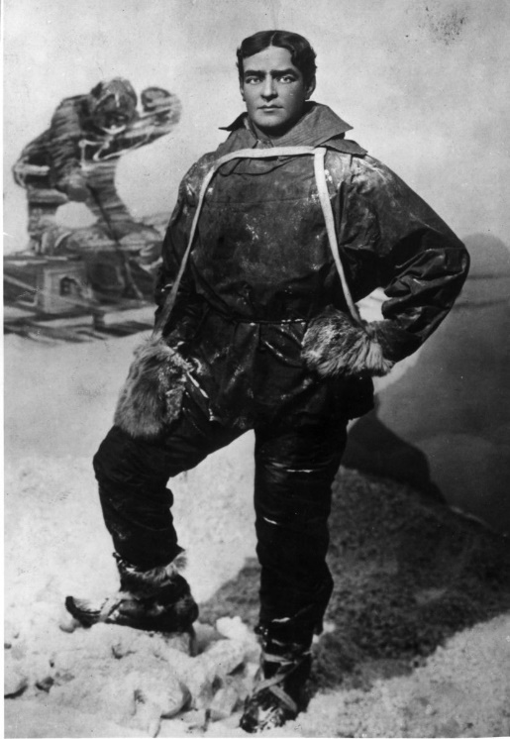
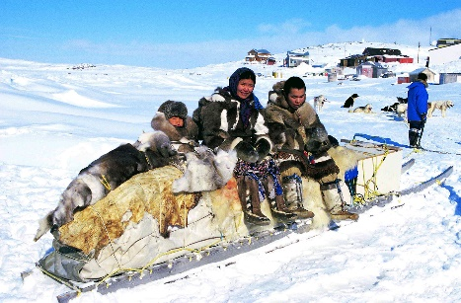

Captain Falon Scott


