Language | Russian
Capital | Moscow
Population | 143.9 million
Currency | Russian ruble ( ₽) (RUB)
President | Vladamir Putin
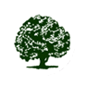
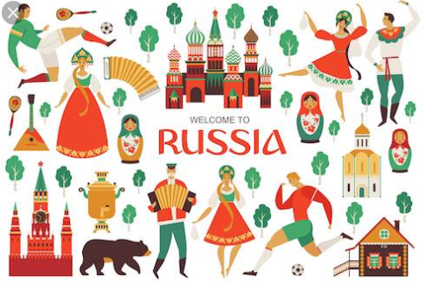
Knowledge Organiser –
Year 3 - Geography- Russia
Key Vocabulary | Definition
Russia | The largest country in the world
Mount Elbas | The tallest mountain in Europe
Velgo River | The longest river in Europe
Baba Yaga | Russian folk tale – witch from the wood
Cyrillic | An Alphabet they use in Russia, named after St. Cyril who translated the Bible into the Russian language
Kremlin | Means castle in Russian. The government is based here
Human geography | The geographical study of people and their communities, cultures, economies, and interactions with the environment.
Physical geography | The geographical study of processes and patterns in the natural environment like the atmosphere, hydrosphere, biosphere, and geosphere
Steppe | Grassland plains without trees, apart from those near rivers and lakes


