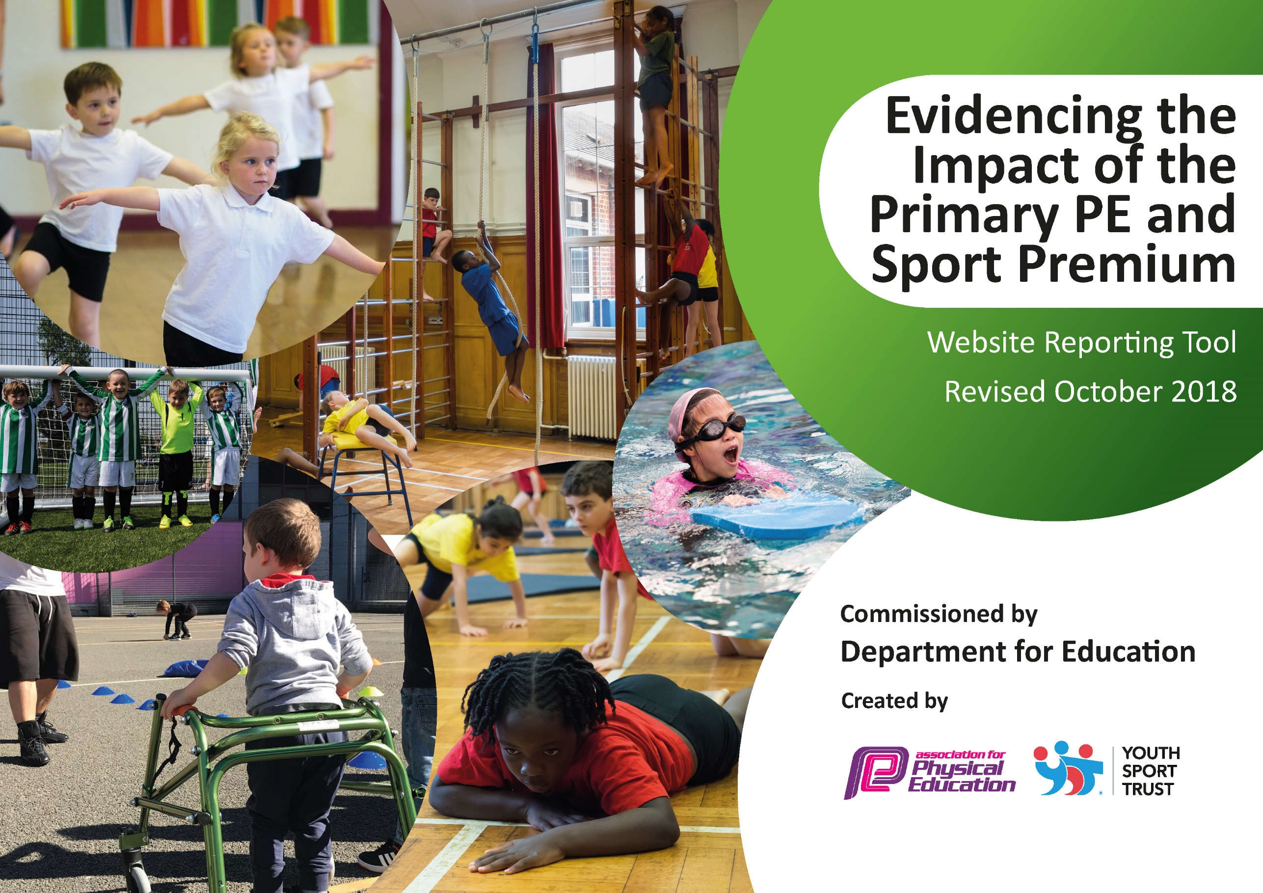
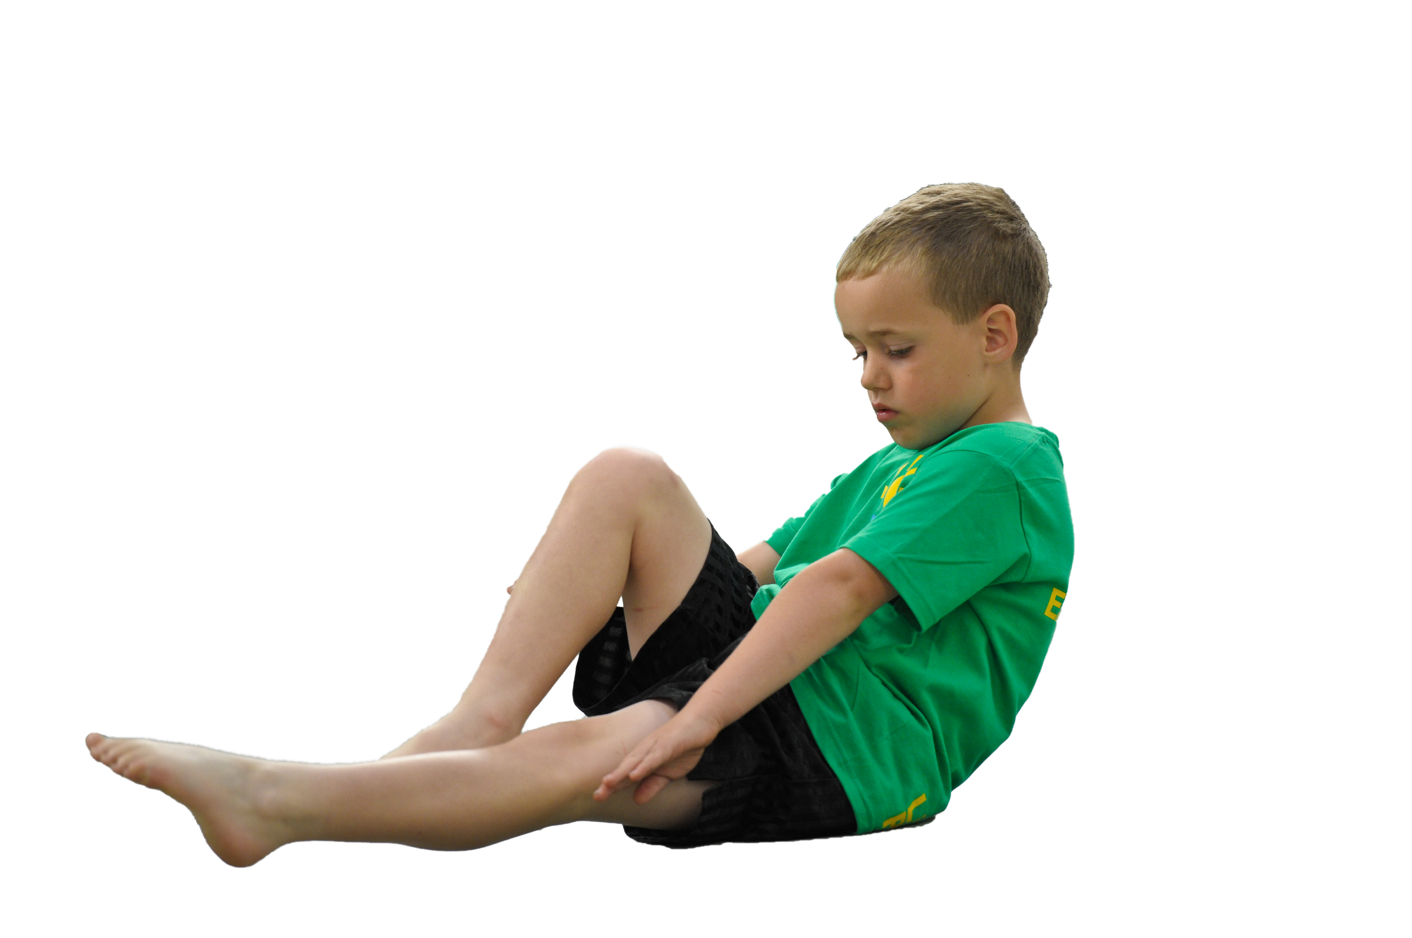
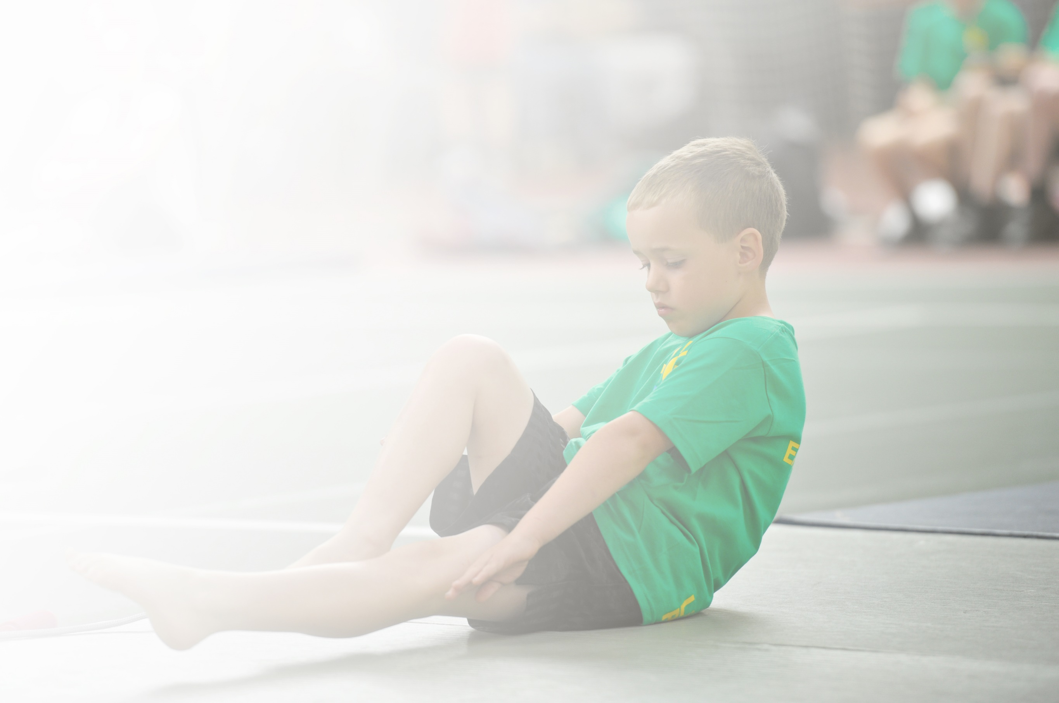
Schools must use the funding to make additional and sustainable improvements to the quality of Physical Education, Sport and Physical Activity (PESPA) they offer. This means that you should use the Primary PE and Sport Premium to:

- Develop or add to the PESPA activities that your school already offer
- Build capacity and capability within the school to ensure that improvements made now will benefit pupils joining the school in future years

Please visit gov.uk for the revised DfE guidance including the 5 key indicators across which schools should demonstrate an improvement. This document will help you to review your provision and to report
your spend. DfE encourages schools to use this template as an effective way of meeting the reporting requirements of the Primary PE and Sport Premium.

We recommend you start by reflecting on the impact of current provision and reviewing the previous
spend. Under the Ofsted Schools Inspection Framework, inspectors will assess how effectively leaders use the Primary PE and Sport Premium and measure its impact on outcomes for pupils, and how effectively governors hold them to account for this.

Schools are required to publish details of how they spend this funding as well as on the impact it has on pupils’ PE and sport participation and attainment by the end of the summer term or by 31 July 2019 at the
latest.
We recommend regularly updating the table and publishing it
on your website throughout the year, as evidence of your
ongoing review into how you are using the money to
secure maximum, sustainable impact. To see an
example of how to complete the table please
click HERE.

Harcourt Primary School – Sport Premium Funding 2018-19

Key achievements to date: | Areas for further improvement and baseline evidence of need:
- Award of Youth Sports Trust Bronze Award  - Increase in the percentage of pupils regularly attending extra-curricular clubs  - Increase in pupils participating in daily physical activity  - All pupils have had the opportunity to experience new sporting activities through ‘taster sessions’.  - Staff are becoming more confident in their delivery of PE and School Sport.  - Harcourt Sporting Team are becoming more competitive in sporting events. | - Continue to develop staffs level of confidence when teaching PE and School Sport  - Provide comprehensive training for Newly Qualified Teachers to ensure their early experiences of teaching PE are meaningful  - Continue to develop the percentage of pupils that participate in intra and inter school competitive sports  - Further develop our skills in early identification of pupils who are G&T in PE and School Sports and ensure they are signposted to appropriate clubs.

Meeting national curriculum requirements for swimming and water safety | Please complete all of the below:
What percentage of your current Year 6 cohort swim competently, confidently and proficiently over a distance of at least 25 metres?  N.B. Even though your children may swim in another year please report on their attainment on leaving  primary school. | 58%
What percentage of your current Year 6 cohort use a range of strokes effectively [for example, front crawl, backstroke and breaststroke]? | 58%
What percentage of your current Year 6 cohort perform safe self-rescue in different water-based situations? | 58%
Schools can choose to use the Primary PE and Sport Premium to provide additional provision for swimming but this must be for activity over and above the national curriculum requirements. Have you used it in this way? | No – but additional Swimming Lessons have been planned for Summer 2019.

Action Plan and Budget Tracking
Capture your intended annual spend against the 5 key indicators. Clarify the success criteria and evidence of impact that you intend to measure to evaluate for students today and for the future.

Academic Year: 2018/19 | Total fund allocated: £ | Date Updated:
Key indicator 1: The engagement of all pupils in regular physical activity – Chief Medical Officer guidelines recommend that primary school children undertake at least 30 minutes of physical activity a day in school |  |  |  | Percentage of total allocation:
 |  |  |  | %
School focus with clarity on intended impact on pupils: | Actions to achieve: | Funding allocated: | Evidence and impact: | Sustainability and suggested next steps:
- Sports Coaches to develop clubs and activities at lunch time and clubs after school to allow more children to be involved in physical activity.  - PE Subject Leader support Sports Ambassadors to lead and run a variety of intra house sports competitions.  - To investigate sports opportunities for all, including those who have been ‘turned off’ sport due to perceived inadequacies in their ability. – Spring / Summer 17 – Clubs audit and pupil voice – Spring 2 | - Where possible, each class from EYFS - 6 will have competed in an Inter Competition  - Bronze Mark Achieved Summer 2018, as evidence of the quality of provision – this quality to be maintained in the future – summer 2018 aiming for Silver.  - Survey pupils. Identify clubs and suitable activities. Signpost clubs to appropriate pupils. Publicise opportunities to pupils and parents | £3572  £350 Training  £300 Resources  £500 Club Subsidy | - Older pupils will begin to run intra school competitions such as dodge ball and a football tournament on sports relief week.  - A greater range of pupils will be involved in sporting activities. More pupils will attend local sports clubs. | - Lunch time games and clubs to be more regular
Key indicator 2: The profile of PESSPA being raised across the school as a tool for whole school improvement |  |  |  | Percentage of total allocation:
 |  |  |  | %
School focus with clarity on intended impact on pupils: | Actions to achieve: | Funding allocated: | Evidence and impact: | Sustainability and suggested next steps:
- Professional Sports Coaches to run clubs at lunch time to get children active and engaged in sports  - Sporting Visitors to attend the school to undertake ‘Sporting Days’ and Special Assemblies  - Weekly Praise Assemblies to include celebration of sporting achievements but at school and out of school  - Sports Leaders to work with other children to develop healthy life styles and healthy break times. | - Coaches to work four lunch times per week  - Coaches to target pupils known to be reluctant to participate  - Arrange visits  - Ensure correct focus of visits  - Development of growth mindset  - Publiscise the need to support this in assembly  - Remind pupils to bring in certificates etc.  - Pupils to be trained  - Pupils sessions to be overseen by MDMS | £3572 (as above)  £1000  No Cost  No additional cost | - Lunch times will become more active  - Pupils behaviour will improve  - Emotional well-being will improve  - Positive role-models will have impact on both sporting and academic success  - Pupils self-esteem will increase  - Pupils will aspire to be like their peers  - Participation will increase. | - Coaches to work closely with MDS and Play Leaders.  - MDMS and PE lead to monitor impact and support as appropriate.

Key indicator 3: Increased confidence, knowledge and skills of all staff in teaching PE and sport |  |  |  | Percentage of total allocation:
 |  |  |  | %
School focus with clarity on intended  impact on pupils: | Actions to achieve: | Funding  allocated: | Evidence and impact: | Sustainability and suggested  next steps:
- Ensure that all NQT have a supported, high quality induction into teaching PE  - Ensure that all teachers have the opportunity to enhance their teaching of PE through appropriate, high quality CPD.  - Relevant CPD for any identified member of staff identified through monitoring | - Elite Coaches to support the teaching of PE through modelled lessons, team-teaching and monitoring.  - All teachers to receive two terms of support, guidance and team-teaching alongside Elite Coaches.  - Lesson observations identify gaps. Identify relevant training. Attend training. | Specialist Support from Elite - £3952  £1200 (including supply costs) | - NQT will be increasingly secure in their teaching of PE and Support  - Lesson Observations will demonstrate a Good standard of teaching in all lessons
Key indicator 4: Broader experience of a range of sports and activities offered to all pupils |  |  |  | Percentage of total allocation:
 |  |  |  | %
School focus with clarity on intended  impact on pupils: | Actions to achieve: | Funding  allocated: | Evidence and impact: | Sustainability and suggested  next steps:
- Ensure that all year groups are given the opportunity to participate in ‘taster sessions’ through the Shepway Sports Trust  - Year 6 pupils to participate in Bike-Ability Safety sessions during Summer Term  - Opportunities for Yr6 to participate in swimming lessons above normal Yr3/4 curriculum offer. | - Meet with Sarah Green.  - Identify appropriate activities  - Book and organise sessions  - Arrange sessions  - Communicate with parents  - Participate in sessions.  - Pupils to attend extra swimming as required  - Pupils assessed against government standard  - Report published online. | £1320  £500  £750 | Children will be safe and confident to use their bikes on the road. | On-going
Key indicator 5: Increased participation in competitive sport |  |  |  | Percentage of total allocation:
 |  |  |  | %
School focus with clarity on intended  impact on pupils: | Actions to achieve: | Funding  allocated: | Evidence and impact: | Sustainability and suggested  next steps:
- Purchase on new team kits to increase levels of pride in the school  - Buy in to the Shepway Sports Trust Competition Package. Access to a number of competitive sporting opportunities. | - Identify provider  - Arrange order  - Purchase kit  - Identify appropriate competitions  - Train teams  - Arrange transport  - Participate in events | £500  £750 competition package  £1600 transport costs

