
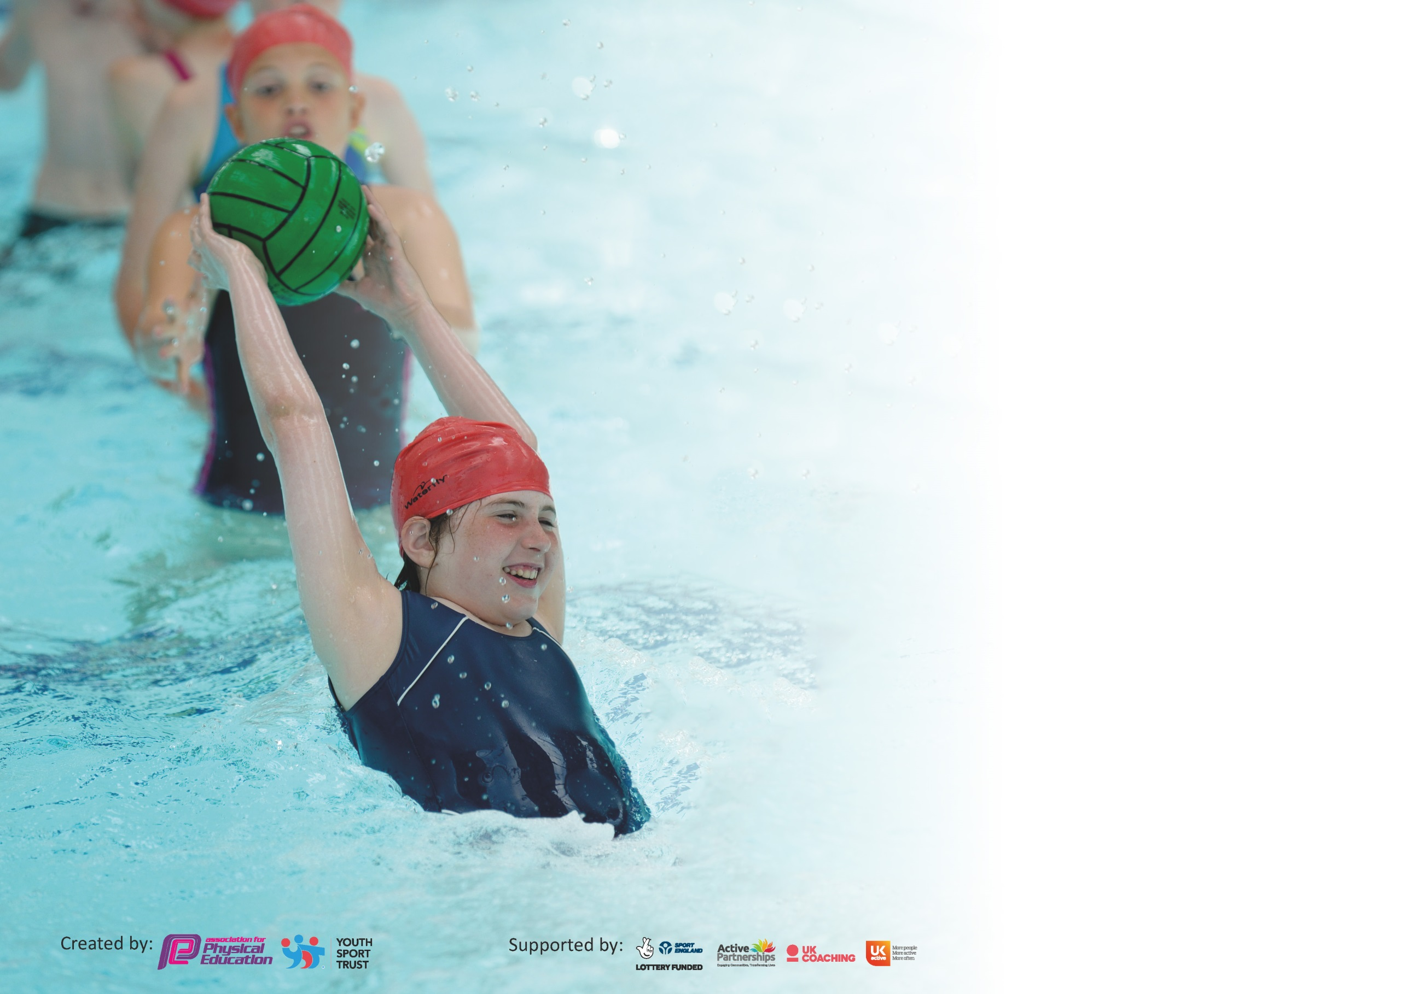

It is important that your grant is used effectively and based on school need. The Education Inspection Framework (Ofsted 2019 p64) makes clear there will be a focus on ‘whether leaders and those responsible for governors all understand their respective roles and perform these in a way that enhances the effectiveness of the school’.

Under the Quality of Education criteria (p41) inspectors consider the extent to which schools can articulate their curriculum (INTENT), construct their curriculum (IMPLEMENTATION) and demonstrate the outcomes which result (IMPACT).

To assist schools with common transferable language this template has been developed to utilise the same three headings which should make your plans easily transferable between working documents.

Schools must use the funding to make additional and sustainable improvements to the quality of Physical Education, School Sport and Physical Activity (PESSPA) they offer. This means that you should
use the Primary PE and Sport Premium to:

- Develop or add to the PESSPA activities that your school already offer
- Build capacity and capability within the school to ensure that improvements made now will benefit pupils joining the school in future years

Please visit gov.uk for the revised DfE guidance including the 5 key indicators across which schools should demonstrate an improvement. This document will help you to review your provision and to report your spend. DfE encourages schools to use this template as an effective way of meeting the reporting requirements of the Primary PE and Sport Premium.

We recommend you start by reflecting on the impact of current provision and reviewing the previous spend.

Schools are required to publish details of how they spend this funding as well as on the impact it has on pupils’ PE and sport participation and attainment by the end of the summer term or by 31st July 2020 at the latest.

We recommend regularly updating the table and publishing it on your website throughout the year. This evidences your ongoing self-evaluation of how you are using the funding to secure maximum, sustainable impact. Final copy must be posted on your website by the end of the academic year and no later than the 31st July 2020. To see an example of how to complete the table please click HERE.

Support for review and reflection - considering the 5 key indicators from DfE, what development needs are a priority for your setting and your pupils now and why? Use the space below to reflect on previous spend and key achievements and areas for development.

Key achievements to date until July 2019: | Areas for further improvement and baseline evidence of need:
- Award of Youth Sports Trust Bronze Award  - in pupils participating in daily physical activity  - All pupils have had the opportunity to experience new sporting activities through ‘taster sessions’.  - Staff are becoming more confident in their delivery of PE and School Sport.  - Harcourt Sporting Team are becoming more competitive in sporting events.  - A greater proportion of pupils are now participating in extra-curricular sporting activities.  - Key Stage On Pupils now participating in a wider range of interschool sporting activities. | - Continue to develop staffs level of confidence when teaching PE and School Sport  - Provide comprehensive training for Newly Qualified Teachers to ensure their early experiences of teaching PE are meaningful  - Continue to develop the percentage of pupils that participate in intra and inter school competitive sports  - Further develop our skills in early identification of pupils who are G&T in PE and School Sports and ensure they are signposted to appropriate clubs.  - Ensure that planning for PE and School Sport continues to develop ensuring far greater progression of skills.

Meeting national curriculum requirements for swimming and water safety.
What percentage of your current Year 6 cohort swim competently, confidently and proficiently over a distance of at least 25 metres?  N.B. Even though your pupils may swim in another year please report on their attainment on leaving  primary school at the end of the summer term 2020. | 71%
What percentage of your current Year 6 cohort use a range of strokes effectively [for example, front crawl, backstroke and breaststroke]? | 71%
What percentage of your current Year 6 cohort perform safe self-rescue in different water-based situations? | 71%
Schools can choose to use the Primary PE and Sport Premium to provide additional provision for swimming but this must be for activity over and above the national curriculum requirements. Have you used it in this way? | Yes

Action Plan and Budget Tracking
Capture your intended annual spend against the 5 key indicators. Clarify the success criteria and evidence of impact that you intend to measure to evaluate for pupils today and for the future.

Academic Year: 2019/20 | Total fund allocated: £17530 | Date Updated: September 2019
Key indicator 1: The engagement of all pupils in regular physical activity – Chief Medical Officer guidelines recommend that primary school pupils undertake at least 30 minutes of physical activity a day in school |  |  |  | Percentage of total allocation:
 |  |  |  | %
Intent | Implementation |  | Impact
To ensure that all pupils take part in regular physical activity during lunch times. | Member of Elite Community Coaching to lead activities | £2850 | Review December 2019
To ensure that 100% of lessons physically challenge all pupils. | Staff training to ensure all staff understand how to physically challenge pupils  PE Leader to activity monitor lessons and the impact they have on pupils health and well-being | £1500 | Review December 2019
Key indicator 2: The profile of PESSPA being raised across the school as a tool for whole school improvement |  |  |  | Percentage of total allocation:
 |  |  |  | %
Intent | Implementation |  | Impact
- Professional Sports Coaches to run clubs at lunch time to get children active and engaged in sports  - Sporting Visitors to attend the school to undertake ‘Sporting Days’ and Special Assemblies  - Weekly Praise Assemblies to include celebration of sporting achievements but at school and out of school  - Sports Leaders to work with other children to develop healthy life styles and healthy break times. | - Coaches to work four lunch times per week  - Coaches to target pupils known to be reluctant to participate  - Arrange visits  - Ensure correct focus of visits  - Development of growth mindset  - Publicise the need to support this in assembly  - Remind pupils to bring in certificates etc.  - Pupils to be trained  - Pupils sessions to be overseen by MDMS | £4750 (including lunch time clubs)  £1000  No Cost  No additional cost

Key indicator 3: Increased confidence, knowledge and skills of all staff in teaching PE and sport |  |  |  | Percentage of total allocation:
 |  |  |  | %
Intent | Implementation |  | Impact
- Ensure that all NQT have a supported, high quality induction into teaching PE  - Ensure that all teachers have the opportunity to enhance their teaching of PE through appropriate, high quality CPD.  - Relevant CPD for any identified member of staff identified through monitoring | - Elite Coaches to support the teaching of PE through modelled lessons, team-teaching and monitoring.  - All teachers to receive two terms of support, guidance and team-teaching alongside Elite Coaches.  - Lesson observations identify gaps. Identify relevant training. Attend training. | Specialist Support from Elite - £3952  £2000(including supply costs)
Key indicator 4: Broader experience of a range of sports and activities offered to all pupils |  |  |  | Percentage of total allocation:
 |  |  |  | %
Intent | Implementation |  | Impact
Your school focus should be clear | Make sure your actions to | Funding | Evidence of impact: what do | Sustainability and suggested
what you want the pupils to know | achieve are linked to your | allocated: | pupils now know and what | next steps:
and be able to do and about | intentions: |  | can they now do? What has
what they need to learn and to |  |  | changed?:
consolidate through practice:
Pupils to participate in a range of new sporting activities through the Shepway Sports Trust. | Planned and targeted activities for each year group  Range of sports coaches to visit the school and lead activities  Signposting of pupils to appropriate community clubs | £1500 | Review December 2019

Key indicator 5: Increased participation in competitive sport |  |  |  | Percentage of total allocation:
 |  |  |  | %
Intent | Implementation |  | Impact
Your school focus should be clear | Make sure your actions to | Funding | Evidence of impact: what do | Sustainability and suggested
what you want the pupils to know | achieve are linked to your | allocated: | pupils now know and what | next steps:
and be able to do and about | intentions: |  | can they now do? What has
what they need to learn and to |  |  | changed?:
consolidate through practice:
For 100% of pupils to participate in intra class/house sporting events.  For 50% of pupils to participate in at least one inter school sporting activity during the academic year | Intra House Sport competition planned for Terms 4 onwards  Book and participate in a range of different sporting festivals and competitions during the academic year. | £250  £750 SST Competition Package  £2500 Transportation Costs.
Total Cost of Sporting Activities - £18202

Signed off by
Head Teacher: | A.Silk
Date: | 3rd September 2019
Subject Leader: | A.Silk
Date: | 3rd September 2019

Planned Sporting Workshops for Staff and Pupils

Activity | Date | Time | Coach/ Teacher | Year Group
Balanceability | TBC | TBC | TBC | EYFS
Ambassador Pod | 5th June | 1:30-2:30pm | Sophie Daws
Tri Golf | 24th Feb | 9:30-10:30am and 10:30-11:30am | Aaron Galbraith | Year 4  Year 5
Fun Factory | 21st Jan | 9am-12o’clock | Sacha Coleman | EYFS & KS1
American Football | 4th March | 1-3pm | Ted Smith and Mary Smith | TBC
Canton Martial Arts | 11th Dec | 9:30-11:30am | Denise Hardy | TBC
Tiempo Dance and Fitness Day | 27th Nov | 9am-3pm | Sharon Perez | All
Boogie Bounce | 9th March | 9am-12o’clock | Claire Holmes | KS2
F51 Festival Week | Please read ‘In the Loop’ for details of dates and how to book in Term 4. You have booked and paid for 2 groups of up to 30 children to attend. Contact Sarah Green on sgo@shepwaysportstrust.org if you have any questions or refer to page 18 of the SST School Sport Brochure. |  |  | Year 5 & 6
Boxfit  (rolled over from 2017/18) | 1st Oct | 1-3pm | Coach Tommy | Year 5 & Year 6
Mini Rugby x5 weeks 2 sessions per week | 27th Feb, 5th, 12th, 19th, 26th March | 9:30-10:15am and 10:15-11am | Mark Hinton | EYFS  Year 2
Mindfulness for Teachers x3 | TBC | TBC | TBC

