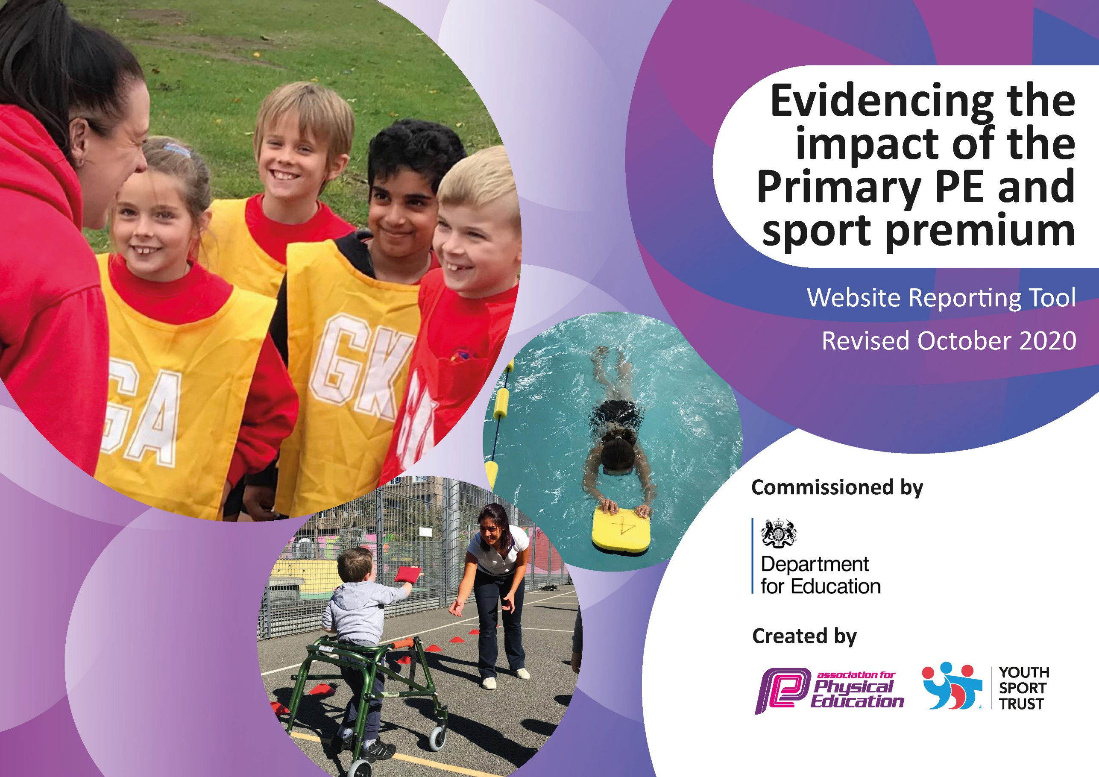
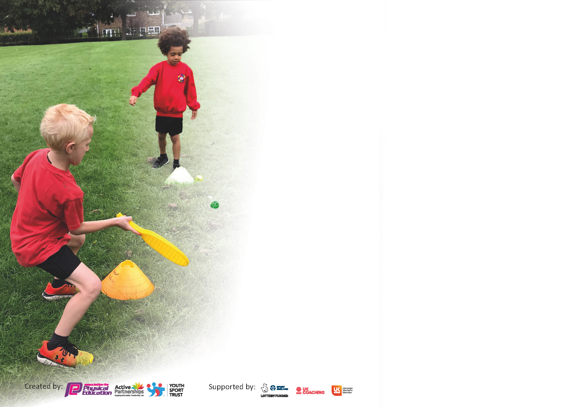

It is important that your grant is used effectively and based on school need. The Education Inspection Framework (Ofsted 2019 p64) makes clear there will be a focus on ‘whether leaders and those responsible for governors all understand their respective roles and perform these in a way that enhances the effectiveness of the school’.

Under the Quality of Education criteria (p41) inspectors consider the extent to which schools can articulate their curriculum (INTENT), construct their curriculum (IMPLEMENTATION) and demonstrate the outcomes which result (IMPACT).

To assist schools with common transferable language this template has been developed to utilise the same three headings which should make your plans easily transferable between working documents.

Schools must use the funding to make additional and sustainable improvements to the quality of Physical Education, School Sport and Physical Activity (PESSPA) they offer. This means that you should use
the Primary PE and sport premium to:

- Develop or add to the PESSPA activities that your school already offer
- Build capacity and capability within the school to ensure that improvements made now will benefit pupils joining the school in future years

Please visit gov.uk for the revised DfE guidance including the 5 key indicators across which schools should demonstrate an improvement. This document will help you to review your
provision and to report your spend. DfE encourages schools to use this template as an effective way of meeting the reporting requirements of the Primary PE and sport premium.

We recommend you start by reflecting on the impact of current provision and reviewing the previous spend.

Schools are required to publish details of how they spend this funding as well as on the impact it has on pupils’ PE and sport participation and attainment by the end of the summer term or by 31st July 2021 at the latest.

** In the case of any under-spend from 2019/20 which has been carried over this must be used and published by 31st March 2021.

We recommend regularly updating the table and publishing it on your website throughout the year. This evidences your ongoing self-evaluation of how you are using the funding to secure maximum, sustainable impact. Final copy must
be posted on your website by the end of the academic year and no later than the 31st July 2021. To see an example of how to complete the table please click HERE.
Created by: Supported by:

Please note: Although there has been considerable disruption in 2020 it is important that you publish details on your website of how you spend the funding - this is a legal requirement.
Support for review and reflection - considering the 5 key indicators from DfE, what development needs are a priority for your setting and your pupils now and why? Use the space below to reflect on previous spend and key achievements and areas for development.

N.B. In this section you should refer to any adjustments you might have made due to Covid-19 and how these will influence further improvement.
Key achievements to date until July 2020: | Areas for further improvement and baseline evidence of need:
- Quality of PE provision was judged as being at least good.  - PE Subject Leader is very experienced and has sufficient time to fulfil his role  - Upskilling of class teachers by specialist PE staff has had a measurable impact on PE delivery  - Through the March to July partial closure PE was still led in school as part of the curriculum for Key Worker and Vulnerable pupils  - Prior to the March 23rd closure a wider range of clubs were being offered to children across KS1 and KS2  - Prior to the March 23rd closure the a wide range of sports offered by our internal sports coaches and through participation in the Shepway Sports Trust programme. | Since Lockdown, children generally have had less opportunities to engage in physical activity. Some of children who have returned to school are less physically fit than before and some appear to have gained weight. We are aware that some children have stayed indoors for long periods of time .  - Increasing fitness levels will need to be a priority for school in September.  - Continue to address issues around obesity and low fitness levels through increasing participation in physical activities  - Increase amount of time for physical activities that ensure children ‘get out of breath’.  - Introduce OAA to the PE curriculum  - Achieve Bronze National Sports mark.  - Continue to offer out a range of after school clubs to increase fitness levels  - Further develop our skills in early identification of pupils who are G&T in PE and School Sports and ensure they are signposted to appropriate clubs.

Did you carry forward an underspend from 2019-20 academic year into the current academic year? NO
Meeting national curriculum requirements for swimming and water safety.

N.B Complete this section to your best ability. For example you might have practised safe self-rescue techniques on dry land.
What percentage of your current Year 6 cohort swim competently, confidently and proficiently over a distance of at least 25 metres?  N.B. Even though your pupils may swim in another year please report on their attainment on leaving primary school at the end of the summer term 2021. | 85%
What percentage of your current Year 6 cohort use a range of strokes effectively [for example, front crawl, backstroke and breaststroke]? | 78%
What percentage of your current Year 6 cohort perform safe self-rescue in different water-based situations? | 85%
Schools can choose to use the Primary PE and sport premium to provide additional provision for swimming but this must be for activity over and above the national curriculum requirements. Have you used it in this way? | Yes

Action Plan and Budget Tracking
Capture your intended annual spend against the 5 key indicators. Clarify the success criteria and evidence of impact that you intend to measure to evaluate for pupils today and for the future.

Academic Year: 2020/21 | Total fund allocated: £ | Date Updated:
Key indicator 1: The engagement of all pupils in regular physical activity – Chief Medical Officers guidelines recommend that primary school pupils undertake at least 30 minutes of physical activity a day in school |  |  |  | Percentage of total allocation:
 |  |  |  | %
Intent | Implementation |  | Impact
Your school focus should be clear what you want the pupils to know and be able to do and about  what they need to learn and to  consolidate through practice: | Make sure your actions to achieve are linked to your intentions: | Funding allocated: | Evidence of impact: what do pupils now know and what can they now do? What has changed?: | Sustainability and suggested next steps:
Offer children at least one free after school club during the year. Working to engage Pupil Premium children and those identified as less active. | Leader will work towards finding an interest of identified children, and then providing this after school club either by an outside coach, or self-taught.  . | £1600 | Review in May 2021 | Continue to involve wider school staff so that less confident staff members can lead their own clubs.
To ensure that pupils participate in active lunch times supporting 30 minutes each day of physical activity. | Continual employment of lunch time sports coaches to run lunch time sports activities. | £5900 | Majority of children will be physically active.  Children will have healthier lifestyles. | Further development of child led play leaders who will have the skills to organise peer activities.
Children will be able to use a range of different lunch time equipment. | Purchase of additional equipment for active lunch times.  To replace tired and faint playground markings . | £500  £3247 | Children will participating and enjoying more active lunch times. | Replacement of consumerable will need to be met through normal school budget post withdrawal of Sports Funding.
Key indicator 2: The profile of PESSPA being raised across the school as a tool for whole school improvement |  |  |  | Percentage of total allocation:
 |  |  |  | %
Intent | Implementation |  | Impact
Your school focus should be clear what you want the pupils to know and be able to do and about  what they need to learn and to  consolidate through practice: | Make sure your actions to achieve are linked to your intentions: | Funding allocated: | Evidence of impact: what do pupils now know and what can they now do? What has changed?: | Sustainability and suggested next steps:
The profile of PE and sport being raised across the school as a tool for whole school improvement. | Children to see evidence of their sporting activities around the school with pictures and display £0 PE board was updated twice in the school year, showing pictures and achievements of the children. We would like to see more children taking part in sports festivals representing the school. | £0 | PE board was updated twice in the school year, showing pictures and achievements of the children.  Children are also celebrated and rewarded for their sporting achievements.
To ensure that pupils are physically as well as mentally well and ready to learn. | Contribution of half cost of Jigsaw PSHE scheme as links to physical and mental well being. | £500 | Children will feel physically and mentally well.  Children will be able to engage in classroom learning as they will be ready to learn.

Key indicator 3: Increased confidence, knowledge and skills of all staff in teaching PE and sport |  |  |  | Percentage of total allocation:
 |  |  |  | %
Intent | Implementation |  | Impact
Your school focus should be clear | Make sure your actions to | Funding | Evidence of impact: what do | Sustainability and suggested
what you want the pupils to know | achieve are linked to your | allocated: | pupils now know and what | next steps:
and be able to do and about | intentions: |  | can they now do? What has
what they need to learn and to |  |  | changed?:
consolidate through practice:
To upskill less confident staff so that they are able to deliver high quality physical activity lessons. | Less confident staff members will work alongside high quality practitioners to upskill themselves. | £800 | All staff will be more confident and skilled when delivering Physical Education.
To provide staff with high quality professional development opportunities through attending course led by Shepway Sports Trust | Identify areas of development in staff’s teaching of PE.  Identify appropriate courses for them to attend.  Attend course. | £2650  Including 10 x days of supply cover. | All staff will be more confident and skilled when delivering Physical Education.
Key indicator 4: Broader experience of a range of sports and activities offered to all pupils |  |  |  | Percentage of total allocation:
 |  |  |  | %
Intent | Implementation |  | Impact
Your school focus should be clear | Make sure your actions to | Funding | Evidence of impact: what do | Sustainability and suggested
what you want the pupils to know | achieve are linked to your | allocated: | pupils now know and what | next steps:
and be able to do and about | intentions: |  | can they now do? What has
what they need to learn and to |  |  | changed?:
consolidate through practice:
Ensure all pupils participate in at least one sporting activity not normally taught in school. | Identify appropriate activities through the SST catalogue  Organise specific sports days for all year groups to participate in  Evaluate the impact of the events | Cost of SST package  £1700 | Pupils will have a wider knowledge of different sporting activities.
Children will be able to access appropriate sporting equipment during PE and extra curricular sport. | Children will have enough of, and appropriate equipment to use. | £1000 | Pupils can engage appropriately in a wide range of sporting activities.

Key indicator 5: Increased participation in competitive sport |  |  |  | Percentage of total allocation:
 |  |  |  | %
Intent | Implementation |  | Impact
Your school focus should be clear | Make sure your actions to | Funding | Evidence of impact: what do | Sustainability and suggested
what you want the pupils to know | achieve are linked to your | allocated: | pupils now know and what | next steps:
and be able to do and about | intentions: |  | can they now do? What has
what they need to learn and to |  |  | changed?:
consolidate through practice:
Pupils will be able to engage in inter and intra sporting events | Identify appropriate events from the SST calendar | £1000 | Children will participate in a number of different competitive activities.
Re-establish house system in school to foster a sense of purpose and competition | House to be re-established  Inter house competitions development (covid allowed) | £250

Signed off by
Head Teacher:
Date:
Subject Leader:
Date:
Governor:
Date:

